**Audiolab augments its flagship 9000 Series with a new range-topping amp system – the 9000Q preamplifier and 9000P stereo power amplifier**

FOR IMMEDIATE RELEASE

Media contact:

Nataliya Potapova

[Nataliya.potapova@eriksonconsumer.com](mailto:Nataliya.potapova@eriksonconsumer.com)

Tel: +1 438 801 3818

**November 26th 2024, BAIE D’URFÉ** – Famed for its integrated amplifiers since 1983’s classic 8000A, Audiolab has also made many renowned multi-chassis amp systems over the years – from the original 8000C/8000Q preamps and 8000P power amp to more recent 8200 and 8300 models.

However, no new Audiolab pre/power components have launched since the 8300XP power amp more than eight years ago. In the time since, the company’s range has been organised into three distinct tiers – 6000, 7000 and 9000 – each including an integrated amp capable of operating as a preamp, power amp or both combined, but no dedicated preamp and power amp components… until now.

The new 9000Q preamplifier and 9000P stereo power amplifier join the award-winning 9000N network streamer, 9000CDT CD transport/media player and 9000A integrated amplifier in Audiolab’s flagship 9000 Series. They build on the design ethos and functionality of the 9000A’s pre and power stages, with newly designed circuitry to deliver the most accomplished amp system in Audiolab’s armoury.

Polishing, elevating and amplifying every aspect of the 9000A’s acclaimed performance, the new 9000Q and 9000P are the epitome of ‘affordable high-end audio’, in line with the 9000 Series’ goal of delivering quality that shoots for the stars but doesn’t cost the earth.

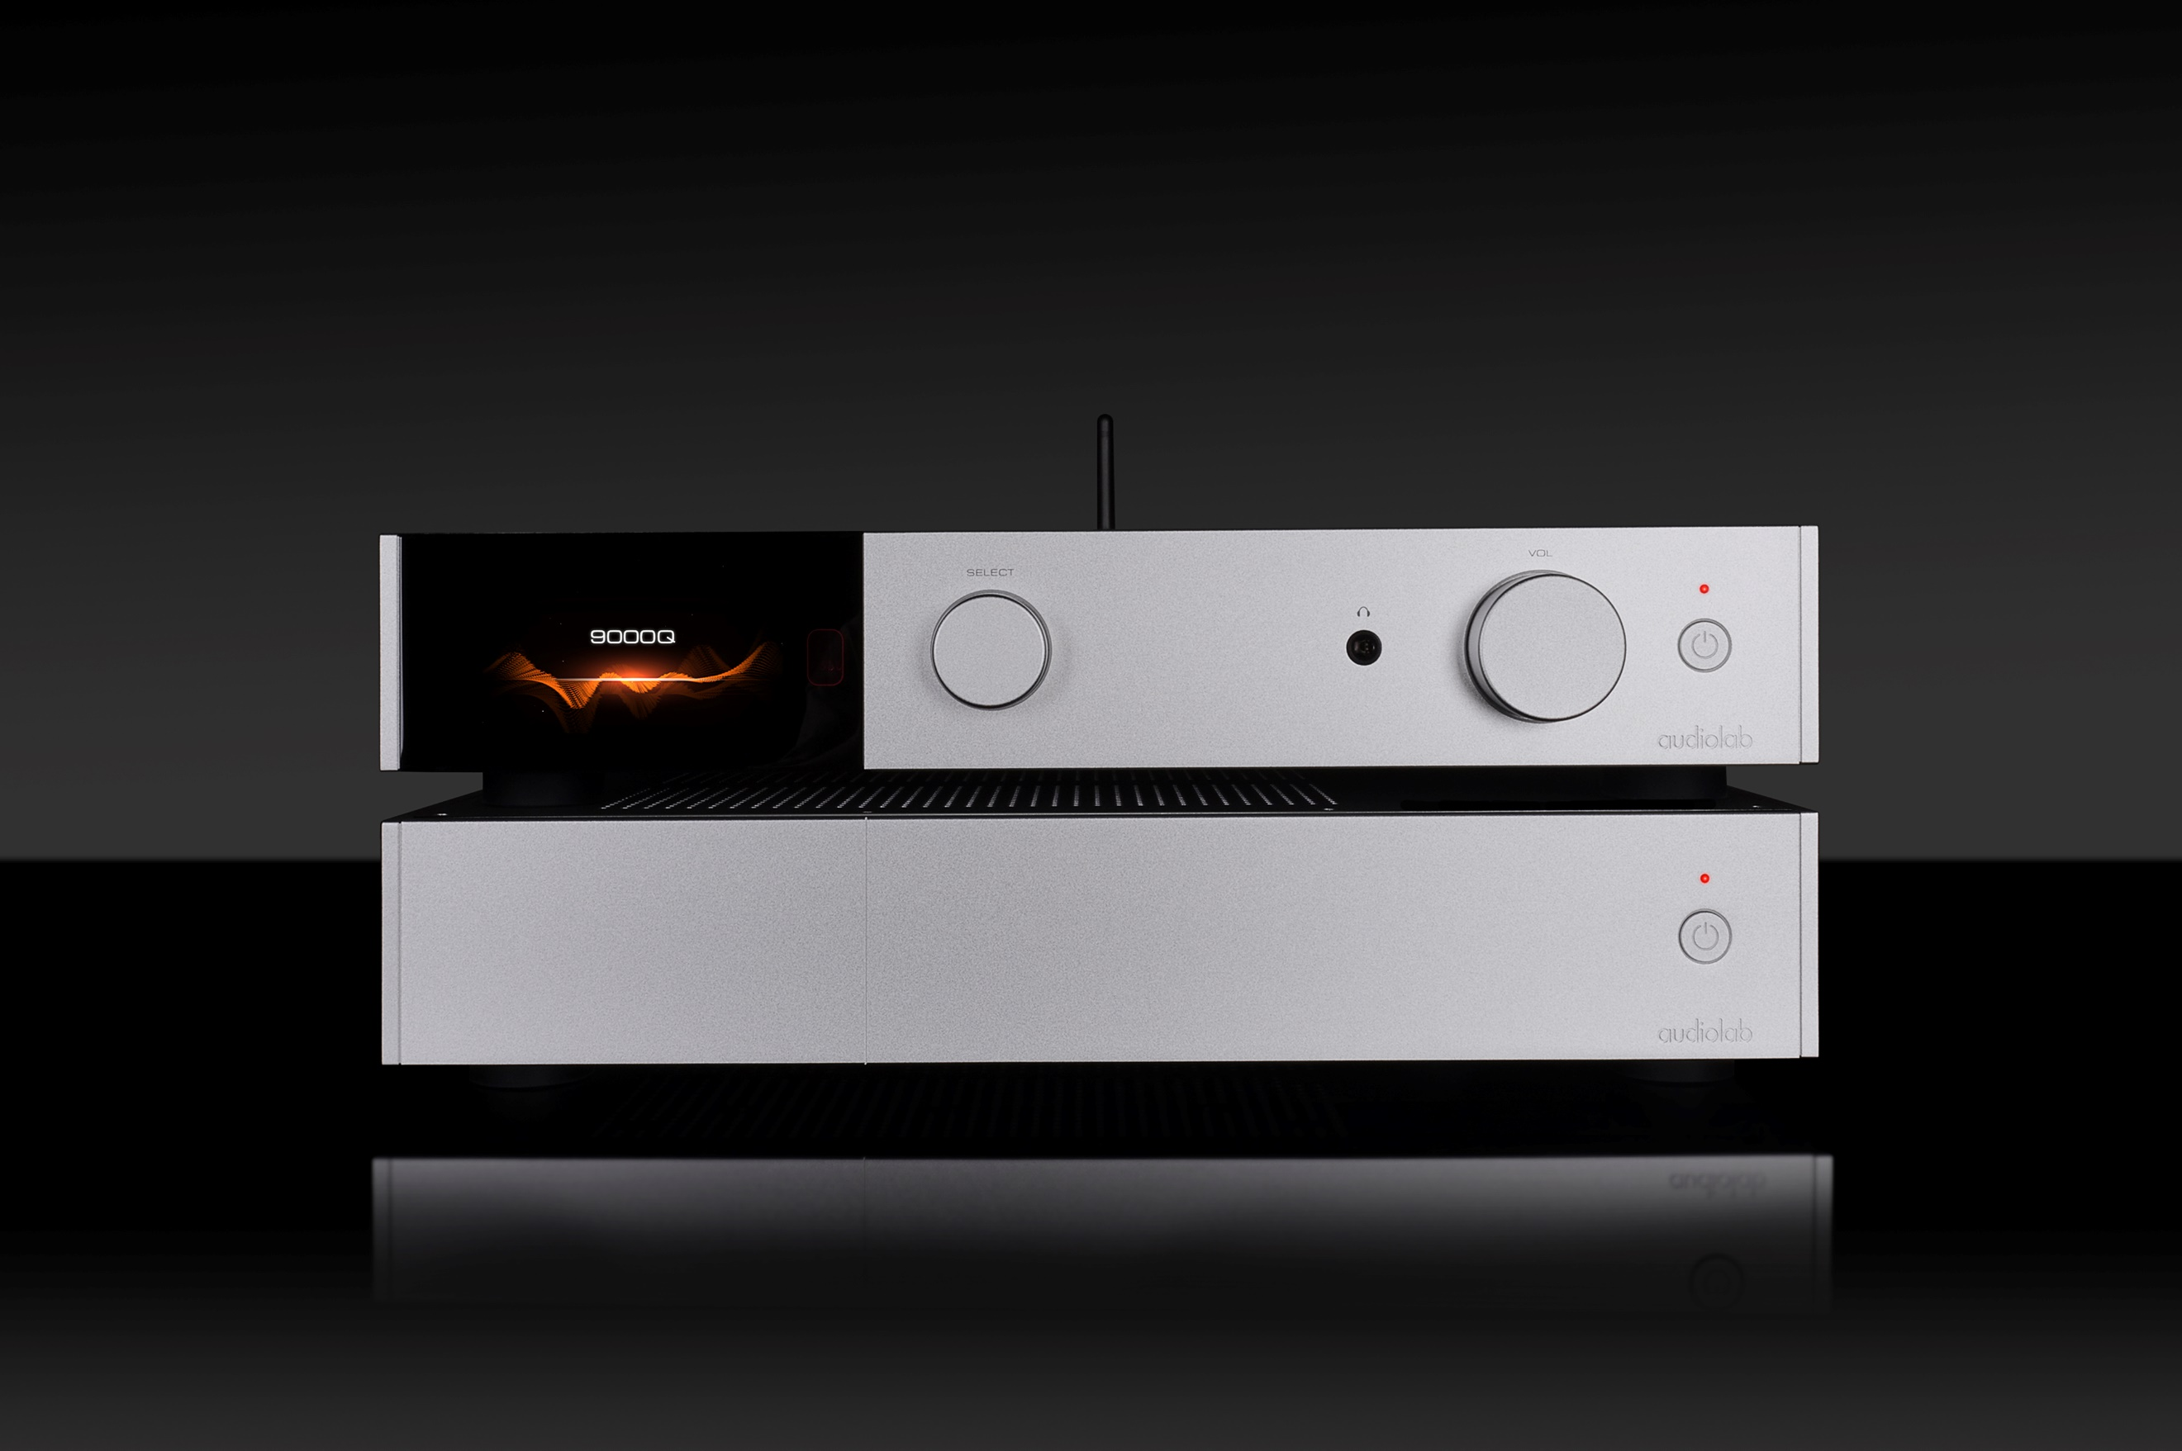

**9000Q Design**

Sharing the now familiar 9000 Series aesthetic, the 9000Q preamplifier is expertly engineered to handle digital and analogue sources with equal accomplishment. Solidly built and impeccably finished, its crisp lines are complemented by two rotary controls and a left-aligned 4.3in colour display.

Combining graphics and data in the same style as other 9000 Series components, the 9000Q’s eye-catching IPS screen displays a variety of information such as volume level, input selection and format data. It also gives access to the amp’s menu system, which includes such options as digital upsampling, input sensitivity adjustment, balance control and automatic standby switching.

Bass and treble tone controls are a new feature added to the 9000Q’s menu system. Although microprocessor controlled, these – like the volume control – operate entirely in the analogue domain and offer precision adjustment of +/-6dB in 2dB steps. Individual settings can be assigned to different digital and analogue inputs – for example, a streaming source and a turntable might benefit from different EQ. These tone controls can also be removed entirely from the signal path if preferred.

As with other 9000 Series components, various display options include a VU-style meter showing real-time decibel levels for the left and right channels as music plays. The display can also be simplified, dimmed or turned off completely, as the user prefers.

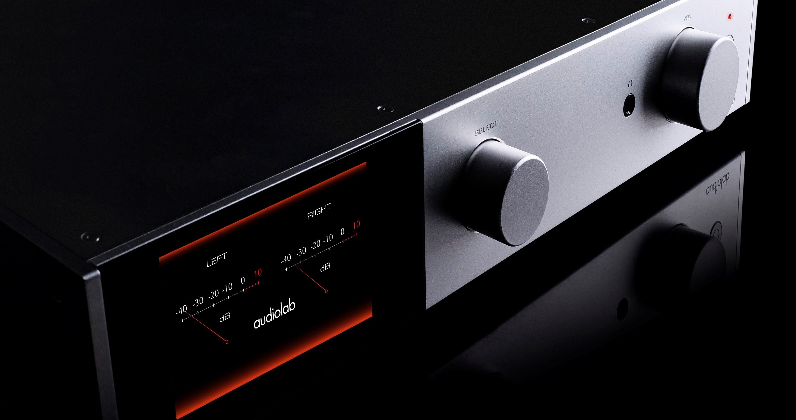 Left: *The 9000Q’s GUI offers many display options including a digital representation of an analogue VU meter.*

**9000Q Connectivity**

The 9000Q incorporates state-of-the-art digital-to-analogue signal conversion, enabling digital sources to be connected directly without an external DAC. A USB Type B input caters for PCs, Macs, smartphones, tablets and digital storage devices, alongside four S/PDIF digital inputs – two coaxial and two optical. There are also four line-level analogue inputs – three stereo RCA and one stereo XLR for balanced connectivity – plus a phono input for a turntable.

Those wishing to stream wirelessly from smartphones, tablets and computers can take advantage of the 9000Q’s high-spec Bluetooth facility, which is Bluetooth 5 compliant for optimum range, speed and reliability. Decoding is included for high-definition Bluetooth formats aptX HD and LDAC, as well as aptX Low Latency, regular aptX, AAC and SBC.

A pair of stereo RCA outputs allow two stereo power amps to be connected – in bridged mode, for example – alongside stereo XLR. The latter benefits from the 9000Q’s balanced circuit topology and ‘Direct XLR’ option, which enables a fully balanced signal path from input to output.

Further flexibility is provided by ‘AV Direct’ mode, which delivers direct throughput from one of the 9000Q’s line-level inputs – useful for connecting an AV processor or another device with its own volume control. There is a fixed-level stereo RCA output too, which also bypasses the volume control, plus a headphone output and a pair of 12V trigger outputs for automated system power up/down.

Left: *A comprehensive array of digital and analogue connection options adds to the 9000Q’s flexibility.*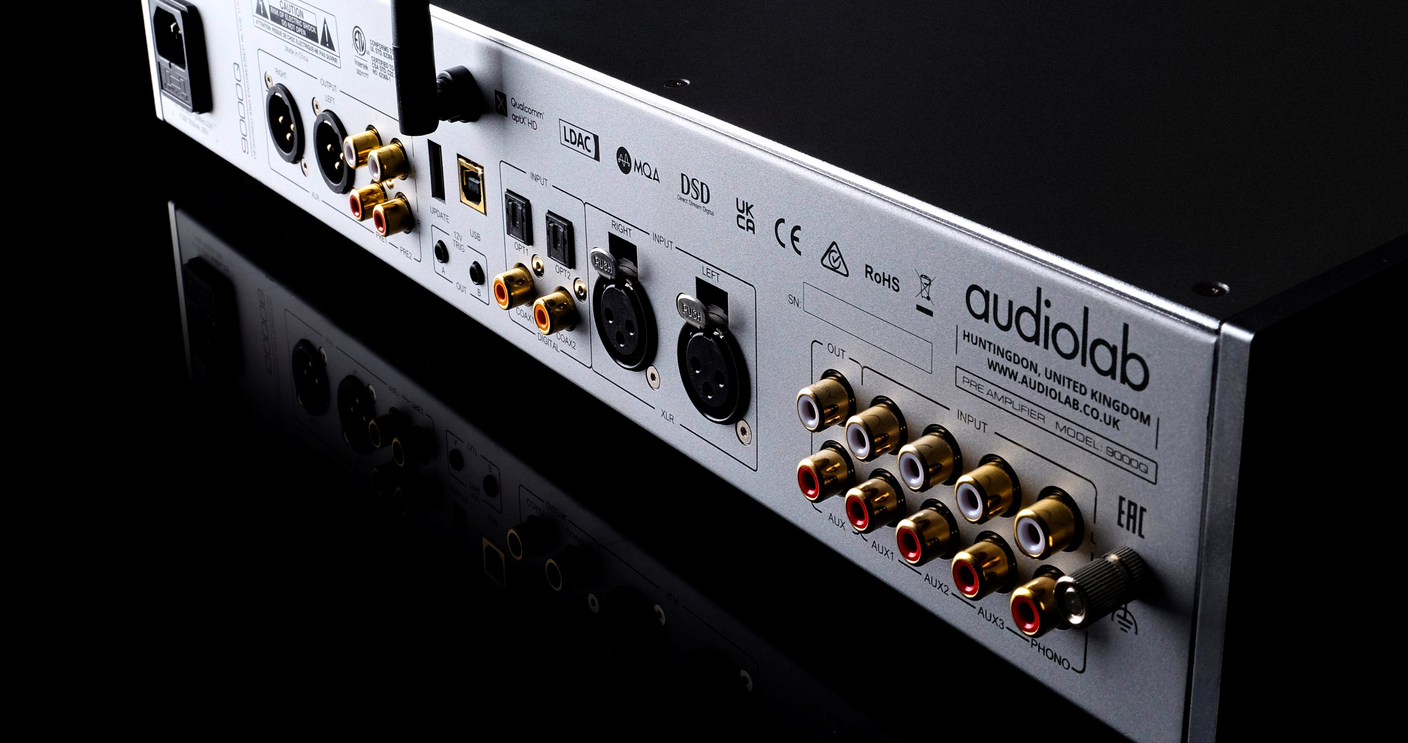

**9000Q Digital-to-Analogue Conversion**

DACs from ESS Technology’s excellent 32-bit Sabre family are now used by many manufacturers, but none rival Audiolab’s experience of designing circuits with these chips. The company was an early adopter of the groundbreaking ES9018, released in 2009 and famously used by Audiolab’s classic 8200CD and M-DAC components which launched the following year.

Since then, Audiolab devices have featured successive generations of Sabre chips, culminating here with the ES9038PRO – a preeminent DAC from the top tier of ESS’s current range. The DAC’s eight channels are fully utilised to deliver a balanced stereo signal, eradicating noise and distortion alongside proprietary Audiolab circuitry including an ultra-precision master clock. This makes the most of the chip’s HyperStream II architecture and Time Domain Jitter Eliminator, enabling exceptional signal-to-noise performance and dynamic range.

Although always technically excellent, Sabre DAC chips are challenging to implement to maximum effect and must be integrated into a product’s circuit design with care to extract their full sonic potential. The post-DAC active filter is a critical element and Audiolab has developed a new Class A circuit for its 9000 Series components that is perfectly tailored to make the most of the ES9038PRO.

The 9000Q’s hi-res audio support is state-of-the-art, handling PCM to 32-bit/768kHz and DSD to 22.5MHz (DSD512). Every significant hi-res and lossless audio format is catered for, including FLAC, ALAC, AIFF and WAV, as well as compressed legacy formats. Full MQA decoding is also included, and the preamp is certified to work seamlessly in a Roon audio environment.

Users can opt to upsample digital audio signals to 352.8kHz or 384kHz, and five DAC reconstruction filter settings allow the listener to adjust the sound to suit the source – particularly useful given the variable quality of digital formats and streaming services. Whether connected via USB, S/PDIF or Bluetooth, every digital source benefits from the exceptional quality of the 9000Q’s DAC stage.

**9000Q Analogue Circuitry**

The 9000Q’s audio circuitry is exceptionally well specified, including a low noise 40VA toroidal transformer and numerous high-grade reservoir/smoothing capacitors and regulators. Its differential balanced topology is designed for maximum signal purity, incorporating a four-channel analogue volume control to permit full control of a balanced signal – in tandem with the XLR Direct mode, this provides a short, direct signal path that remains fully balanced throughout. When other options such as tone adjustment are switched into the signal path, the precision-engineered application of these microprocessor-controlled functions maintains optimal signal purity.

Left: *The 9000Q’s digital and analogue audio circuitry delivers and exceptional blend of versatility and performance.*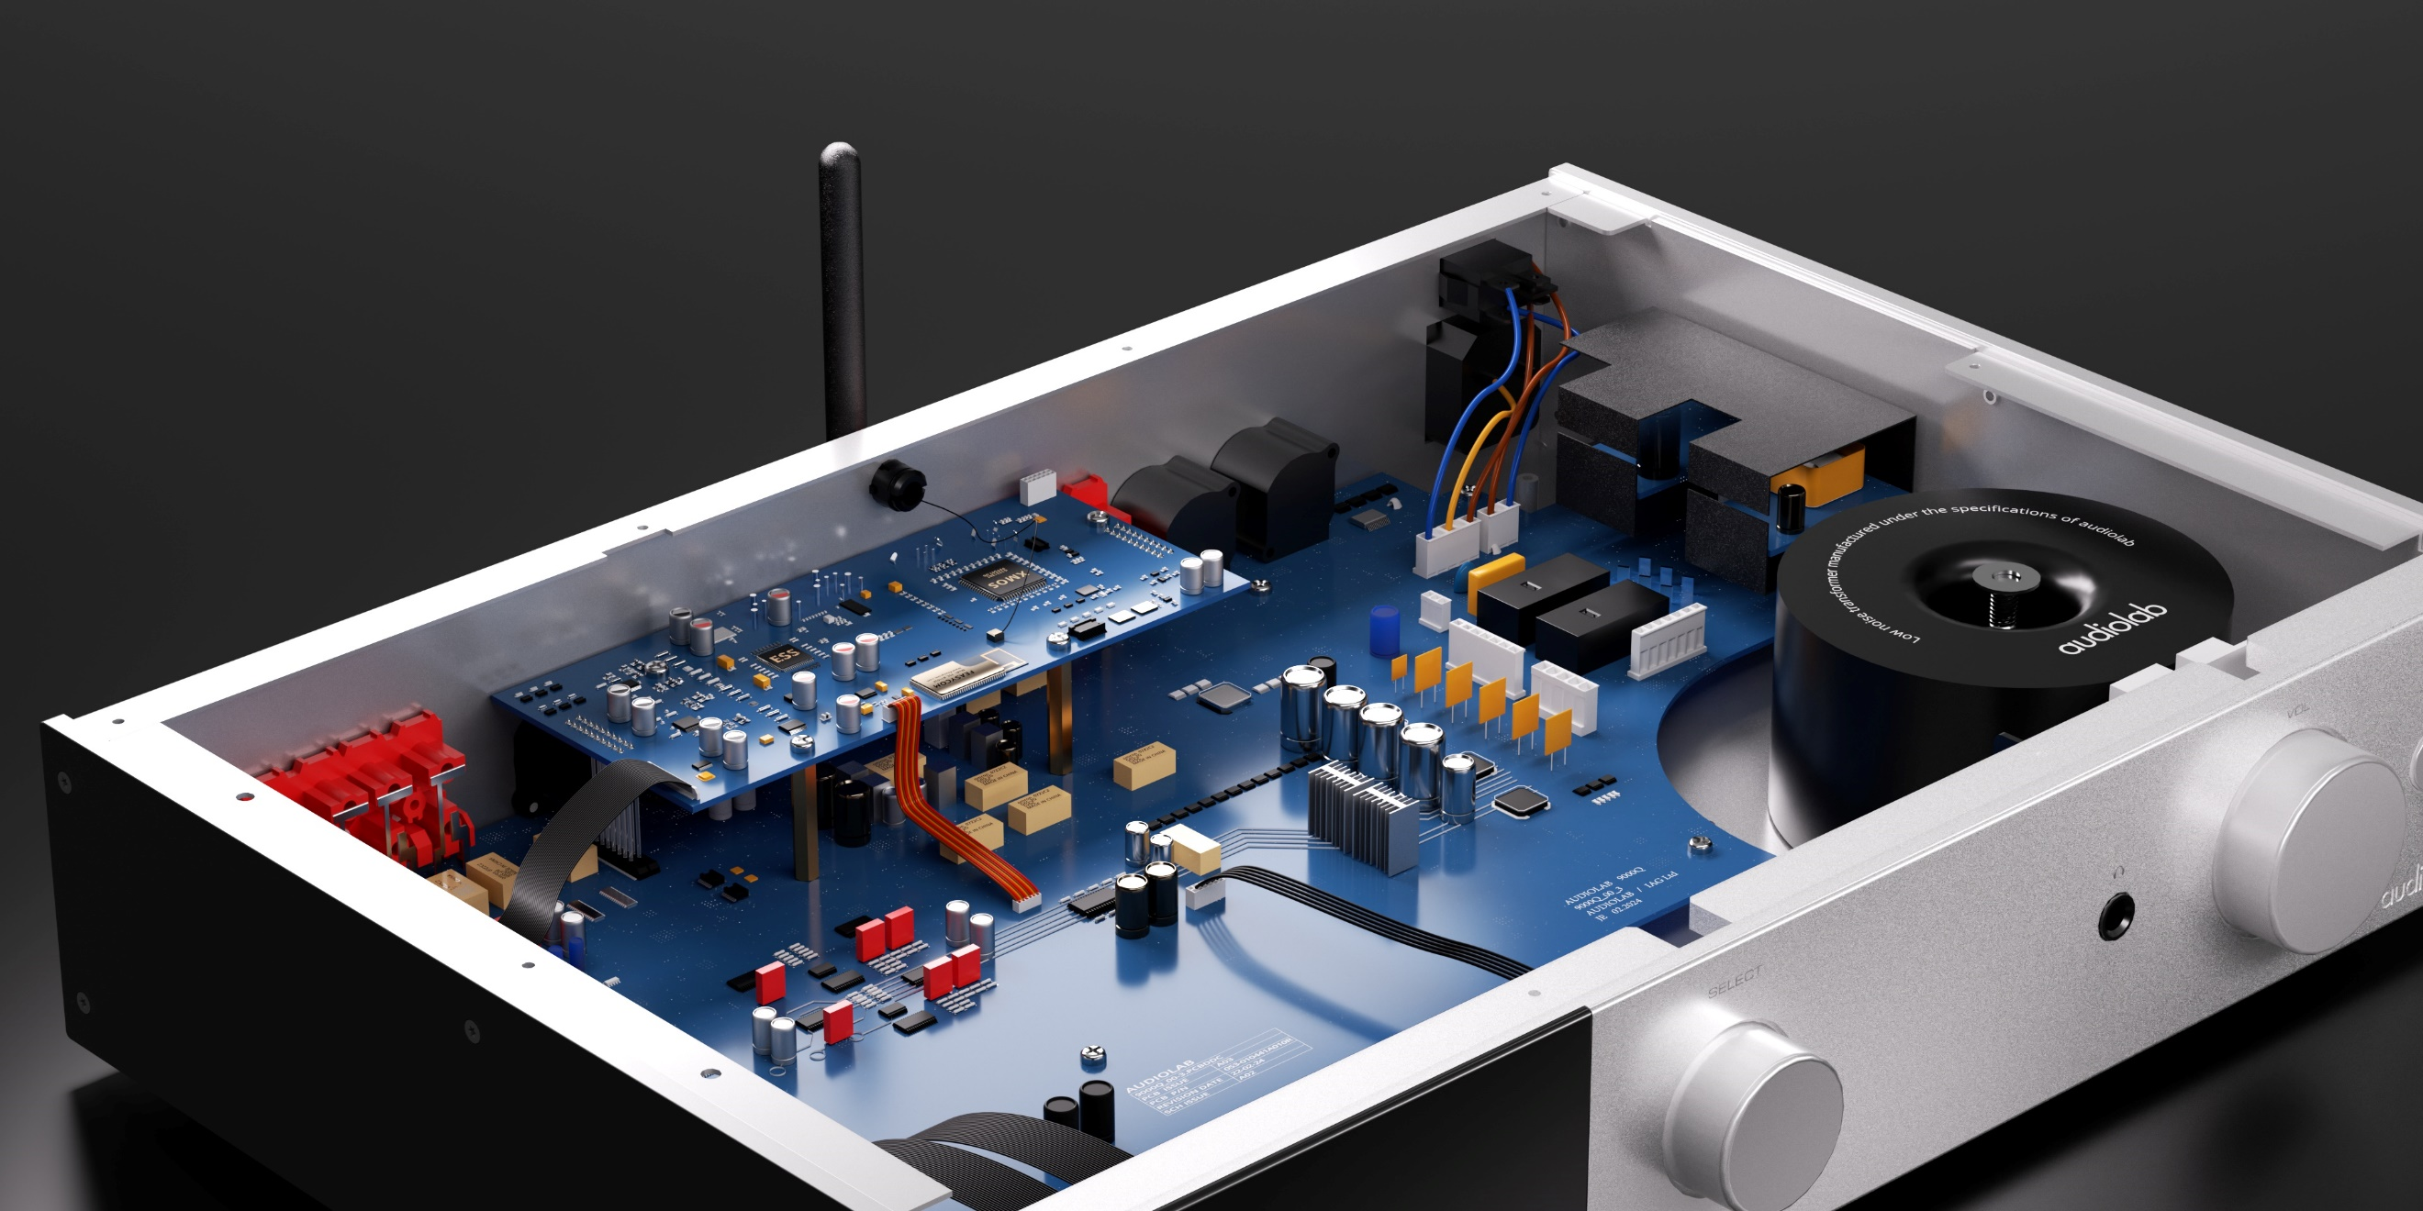

Audiolab has further improved the phono stage developed originally for the 9000A, ensuring vinyl is treated with the same care as digital sources. Thanks to a high-quality, low-noise circuit with precise RIAA equalisation, sophisticated input filtering and an upgraded power supply, every drop of detail that’s dug from a record’s grooves is conveyed with engaging energy and crystal clarity.

The phono stage handles moving magnet (MM) cartridges but is not switchable to suit low output moving coil (MC) types, for good reason. Phono stages built into integrated amps and preamps that cater for both MM and MC cartridges are usually a compromise; a good MC cartridge will benefit greatly from a high-quality offboard phono stage. Rather than cover both bases to a merely adequate degree, Audiolab decided to focus solely on making an excellent MM phono stage – for users of this more common cartridge type, this is all the phono stage they will need.

Headphone listeners are equally well served by the 9000Q’s dedicated headphone amplifier. Its current-feedback design and low output impedance deliver a dynamic and detailed performance with all manner of headphones – even tough loads that many amps’ headphone outputs struggle to drive.

**9000Q Power Supply Circuitry**

The 9000Q’s power supply incorporates 11 regulated supply rails including numerous ultra-low-noise regulators, with extensive measures against contamination and cross-coupling. Critical to its performance, the DAC circuitry includes multiple discrete regulators supplying power separately to the left and right channels for each stage of the digital-to-analogue conversion process. In comparison to the already excellent DAC in the 9000A integrated amp, a separate transformer winding isolates a ‘noisy’ part of the DAC circuit by supplying it directly, thus elevating sound quality even further.

Uniquely, the 9000Q’s power supply benefits from integrated filtering technology developed from Audiolab’s DC Block and DC Block 6 mains optimisation devices. This removes RFI/EMI from the mains supply, reducing differential-mode noise (exacerbated by cheap switch-mode power supplies in many home appliances) and common-mode noise (aggravated by airborne interference from phones, Wi-Fi and Bluetooth). This sinks the noise floor further, imbuing even greater focus and clarity.

Left: *The perfect partner for the 9000Q, Audiolab’s 9000P stereo power amp is a powerful and versatile design.*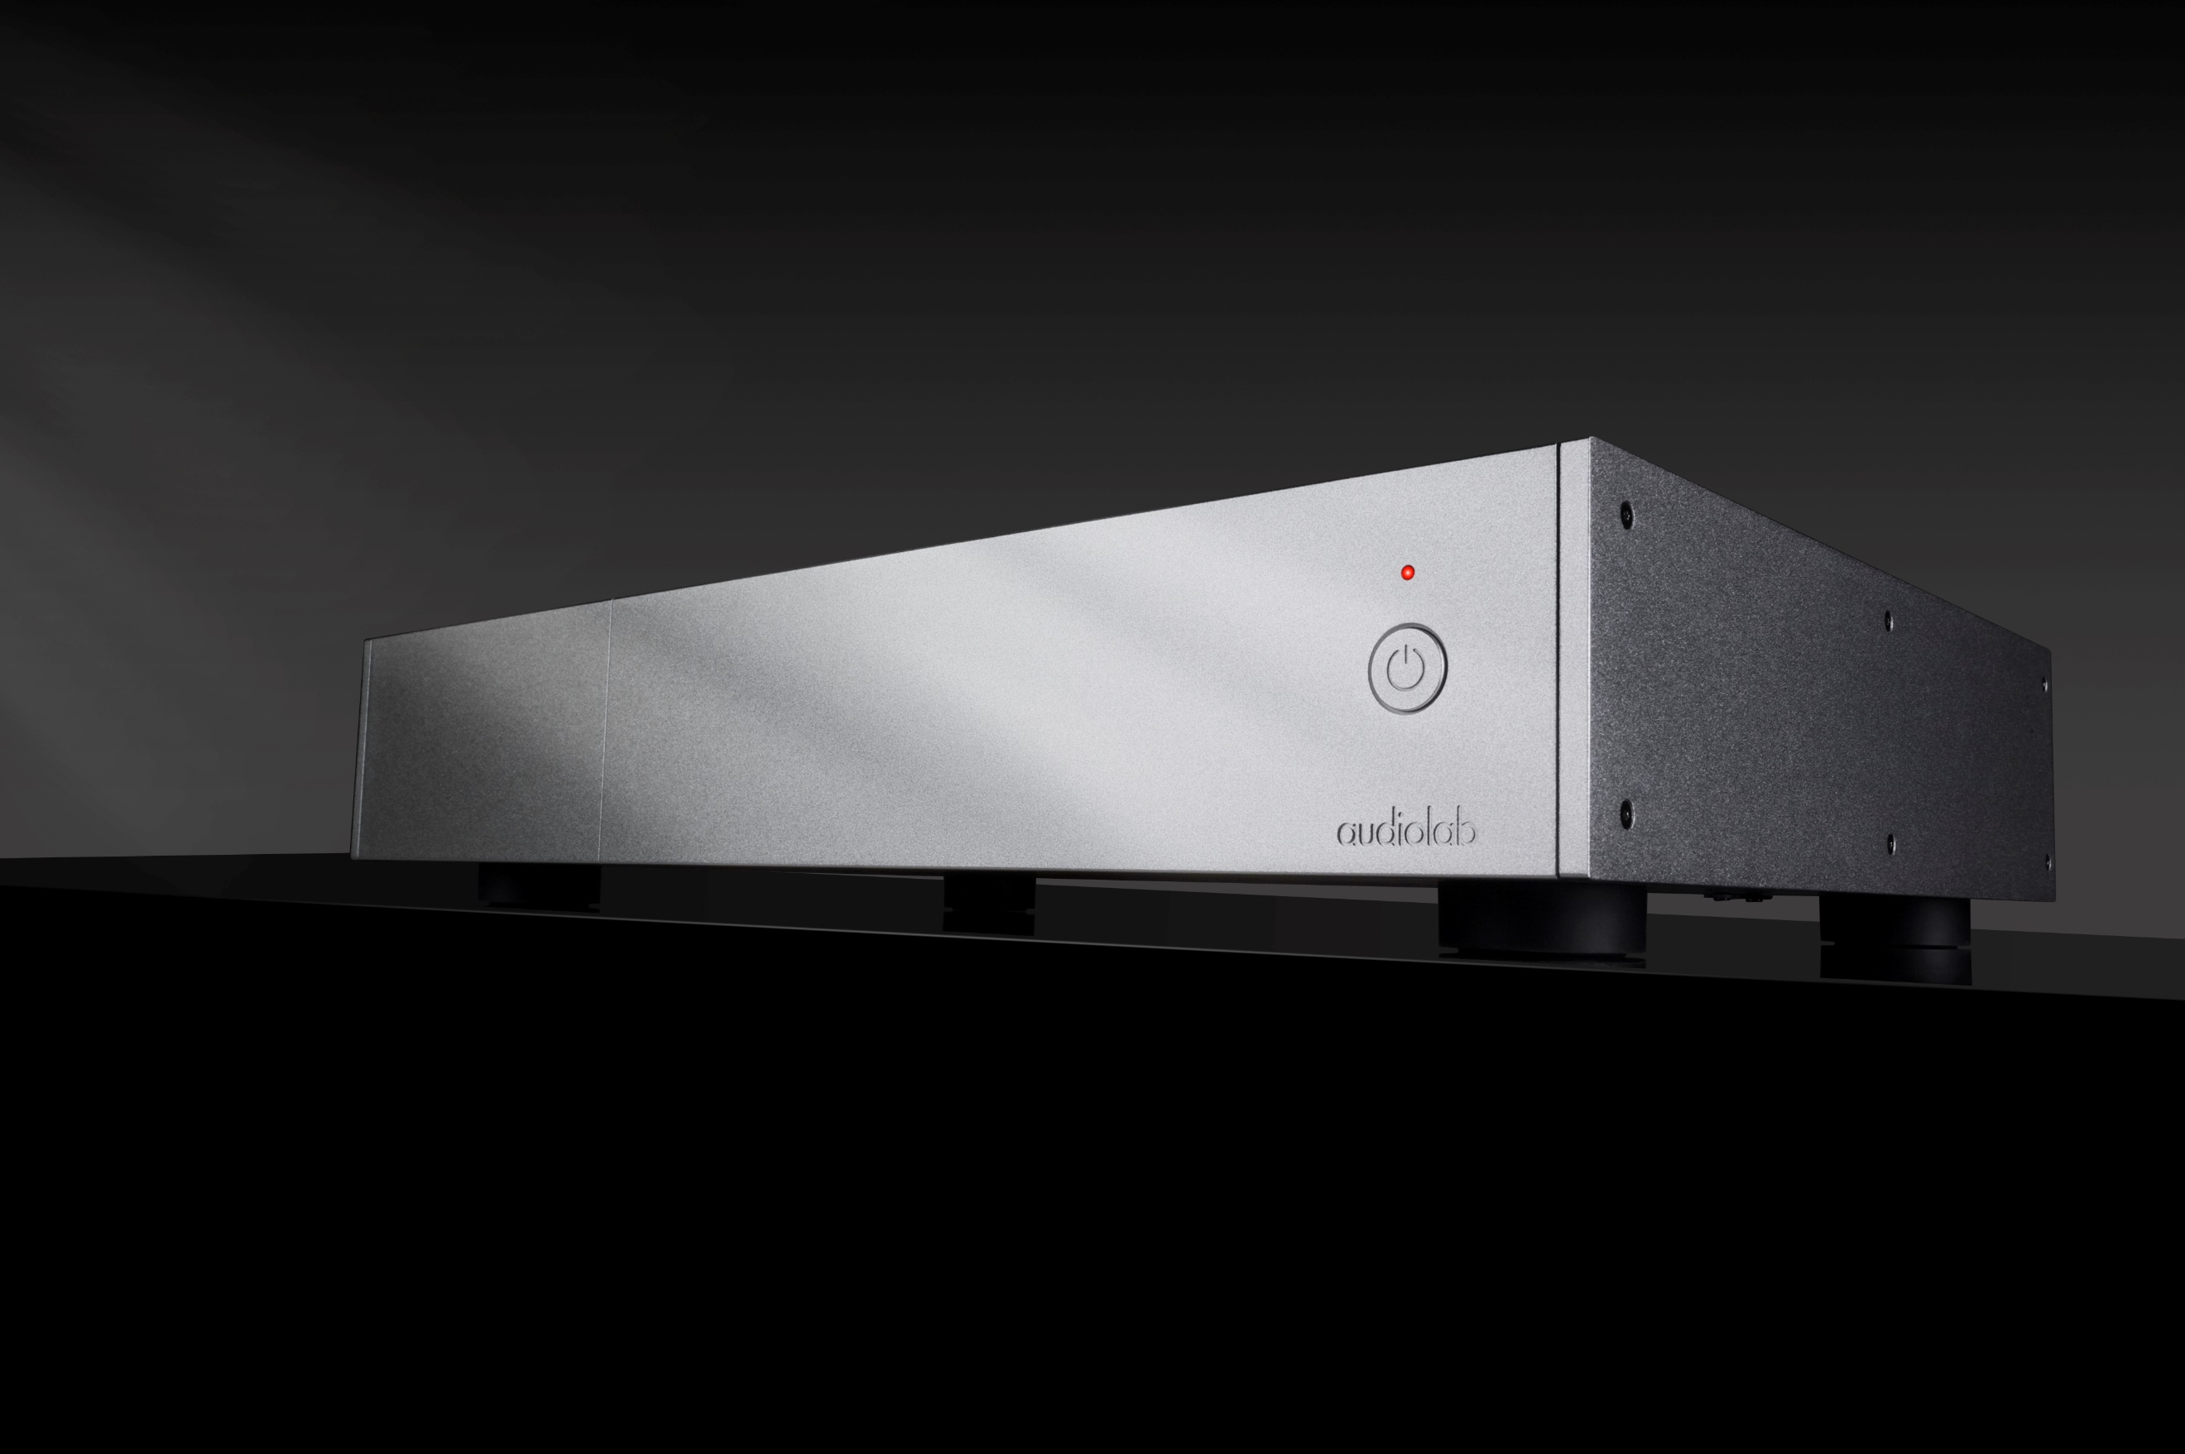

**9000P Design**

With an identically sized chassis to every other 9000 Series component, the 9000P stereo power amplifier is a perfect match visually as well as sonically. The colour screen is not needed here but an etched vertical line marks where the right edge of the display would be if this were a different 9000 Series model. The right-aligned power button, LED and etched Audiolab logo are identical too. When stacked, perhaps on the shelves of a dedicated hi-fi support, few multi-component audio systems look as crisp, classy and immaculately dressed as a collection of 9000 Series devices.

Around the back, stereo RCA and XLR inputs are supplied alongside a 12V trigger input to automatically switch the power amp on/off in line with the connected system. A set of high-quality gold-plated binding posts is provided to connect a pair of speakers.

The inclusion of a separate power amplifier in the 9000 Series broadens the range of potential system configurations. The 9000Q preamplifier is a natural partner, of course, but it can also be connected directly to source devices that have their own volume controls and pre-out sockets. The 9000N network streamer, recipient of What Hi-Fi?’s coveted 2024 Product of the Year Award, is a case in point – together, the 9000N and 9000P make a fabulously capable music streaming system. Just add speakers!

**9000P Circuitry**

The 9000P draws on Audiolab’s expertise built through more than four decades of Class AB amplifier research and design to deliver its best power amp yet. Building on the 9000A integrated amplifier’s power amp stage, it features a dual-mono circuit topology with separate power supplies for the left and right channels, producing excellent detail resolution and spacious, well-defined stereo imaging.

With a rating of 100W per channel into 8 ohms, the output stage uses a CFB (Complementary Feedback) design, delivering superior linearity and excellent thermal stability as the idle current is kept independent of the temperature of the output transistors. A powerful, low noise 320VA toroidal transformer combines with 60,000uF reservoir capacitance and four output transistors per channel, specifically configured to improve linearity under difficult load conditions and capable of delivering maximum output current of 15A per channel.

This high current drive capability ensures the output stage stays under minimum stress, leaving the rest of the amplifier free to operate under optimal conditions. Along with the generous power output, this enables the 9000P to drive power-hungry speakers with consummate ease and plenty in reserve.

Left: *With its dual-mono topology and CFB circuit design, the 9000P delivers power and finesse in spades.*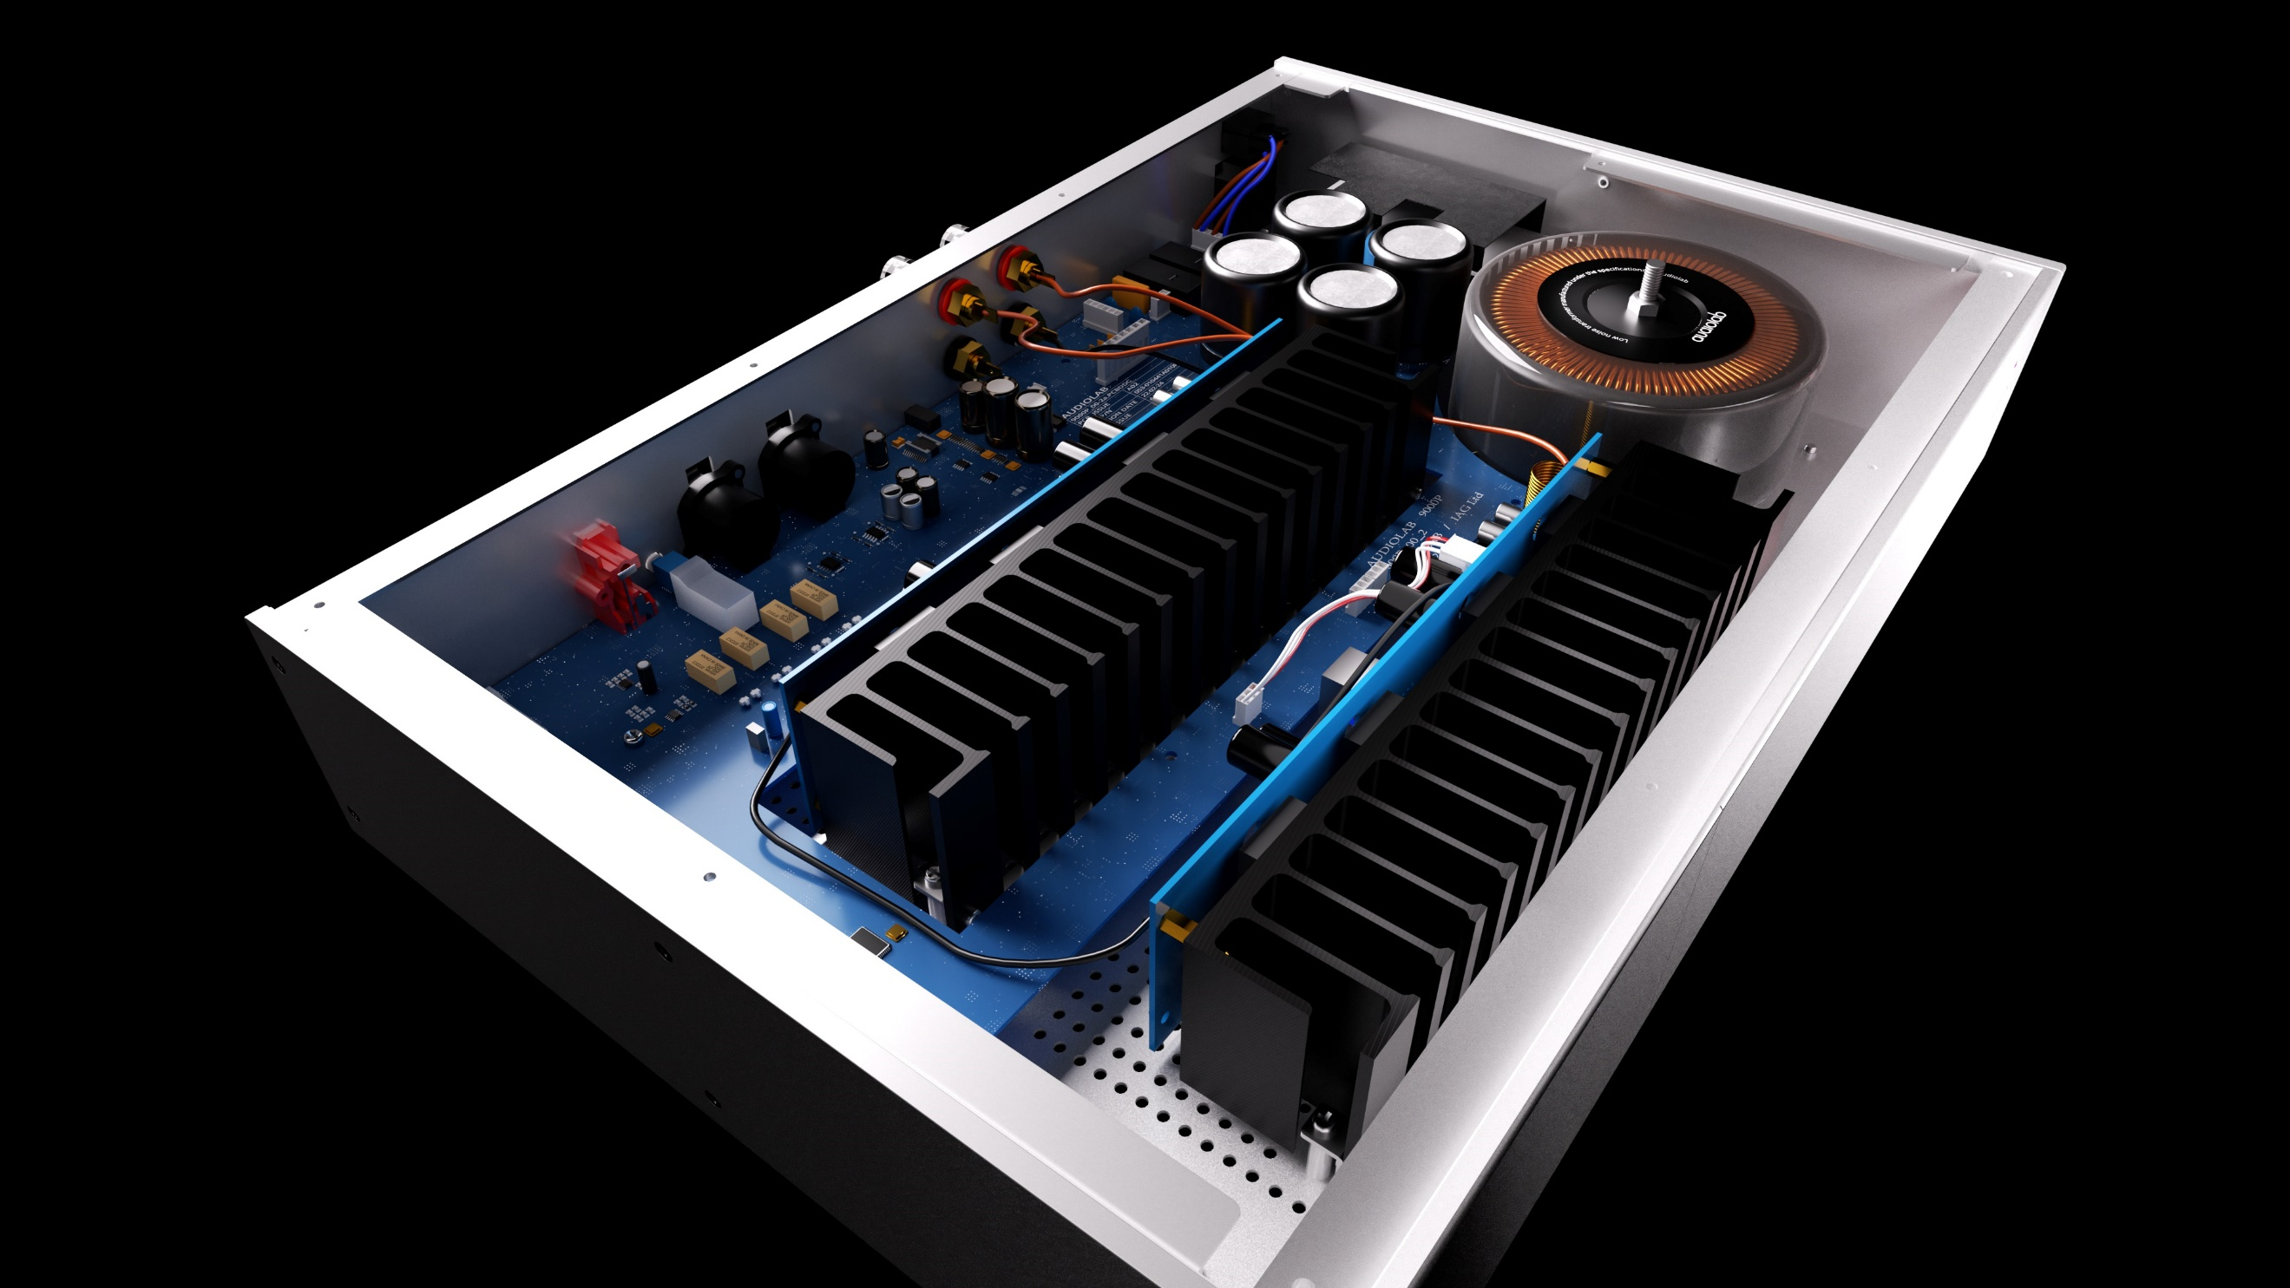

Like the 9000Q preamp, the 9000P’s power supply incorporates sophisticated mains filtering, further elevating sonic performance. The net result is an amp that delivers wide ranging, free breathing dynamics whilst retaining a vice-like grip on the music and revealing the subtlest details in any recording, whatever the volume setting.

The 9000P also offers an upgrade path through the ability to connect two 9000Ps in bridged mode, combining each power amp’s stereo channels into a single mono channel so each unit drives one speaker. This increases the power output to 300W per channel into an 8-ohm load, further elevating sonic muscle and control without compromising the 9000P’s spellbinding finesse.

**A few words from the design team**

The 9000Q/9000P’s design team was led by Jan Ertner, a man whose record of delivering market-leading audio electronics speaks for itself. The challenge was to deliver Audiolab’s best-ever pre/power amp system, as Audiolab director Jamie O’Callaghan explains:

“As well as encapsulating Audiolab’s combined ethos of design, functionality and performance, Jan and his team were tasked with ensuring that each 9000 Series component is the best we’ve ever produced. The 9000A had to be the finest integrated amp; the 9000CDT the best CD transport; and the 9000N the most accomplished network audio streamer. We believe we’ve achieved this goal in every case, delivering exceptional performance at prices befitting a flagship range but still affordable for many.

“Robust, versatile design has been at the heart of the Audiolab brand since the arrival of the original 8000A in 1983. To fulfil its role as Audiolab’s best-ever preamplfier, the 9000Q needs to reflect this versatility in a way that’s relevant to discerning music lovers in 2024 and beyond. This means equal accomplishment with all manner of digital and analogue sources, from smartphones, computers and streamers to CD players, tuners and turntables, striking an ideal balance between useful versatility and absolute sonic purity.

“Equally, the 9000P stereo power amp needs to fit seamlessly into a variety of system configurations, its flexibility enhanced by its robust design and dual-mono architecture, its high power and current drive capabilities, and the facility to combine two amps in bridged mono mode.

“Above all, whether used together or deployed separately, the 9000Q and 9000P must deliver Audiolab’s best sonic performance. We believe they raise the bar, not only within the Audiolab range but across the entire industry at their retail price points.”

Left: *Audiolab’s award-winning 9000N network streamer (middle) is a brilliant match with the 9000Q/P.*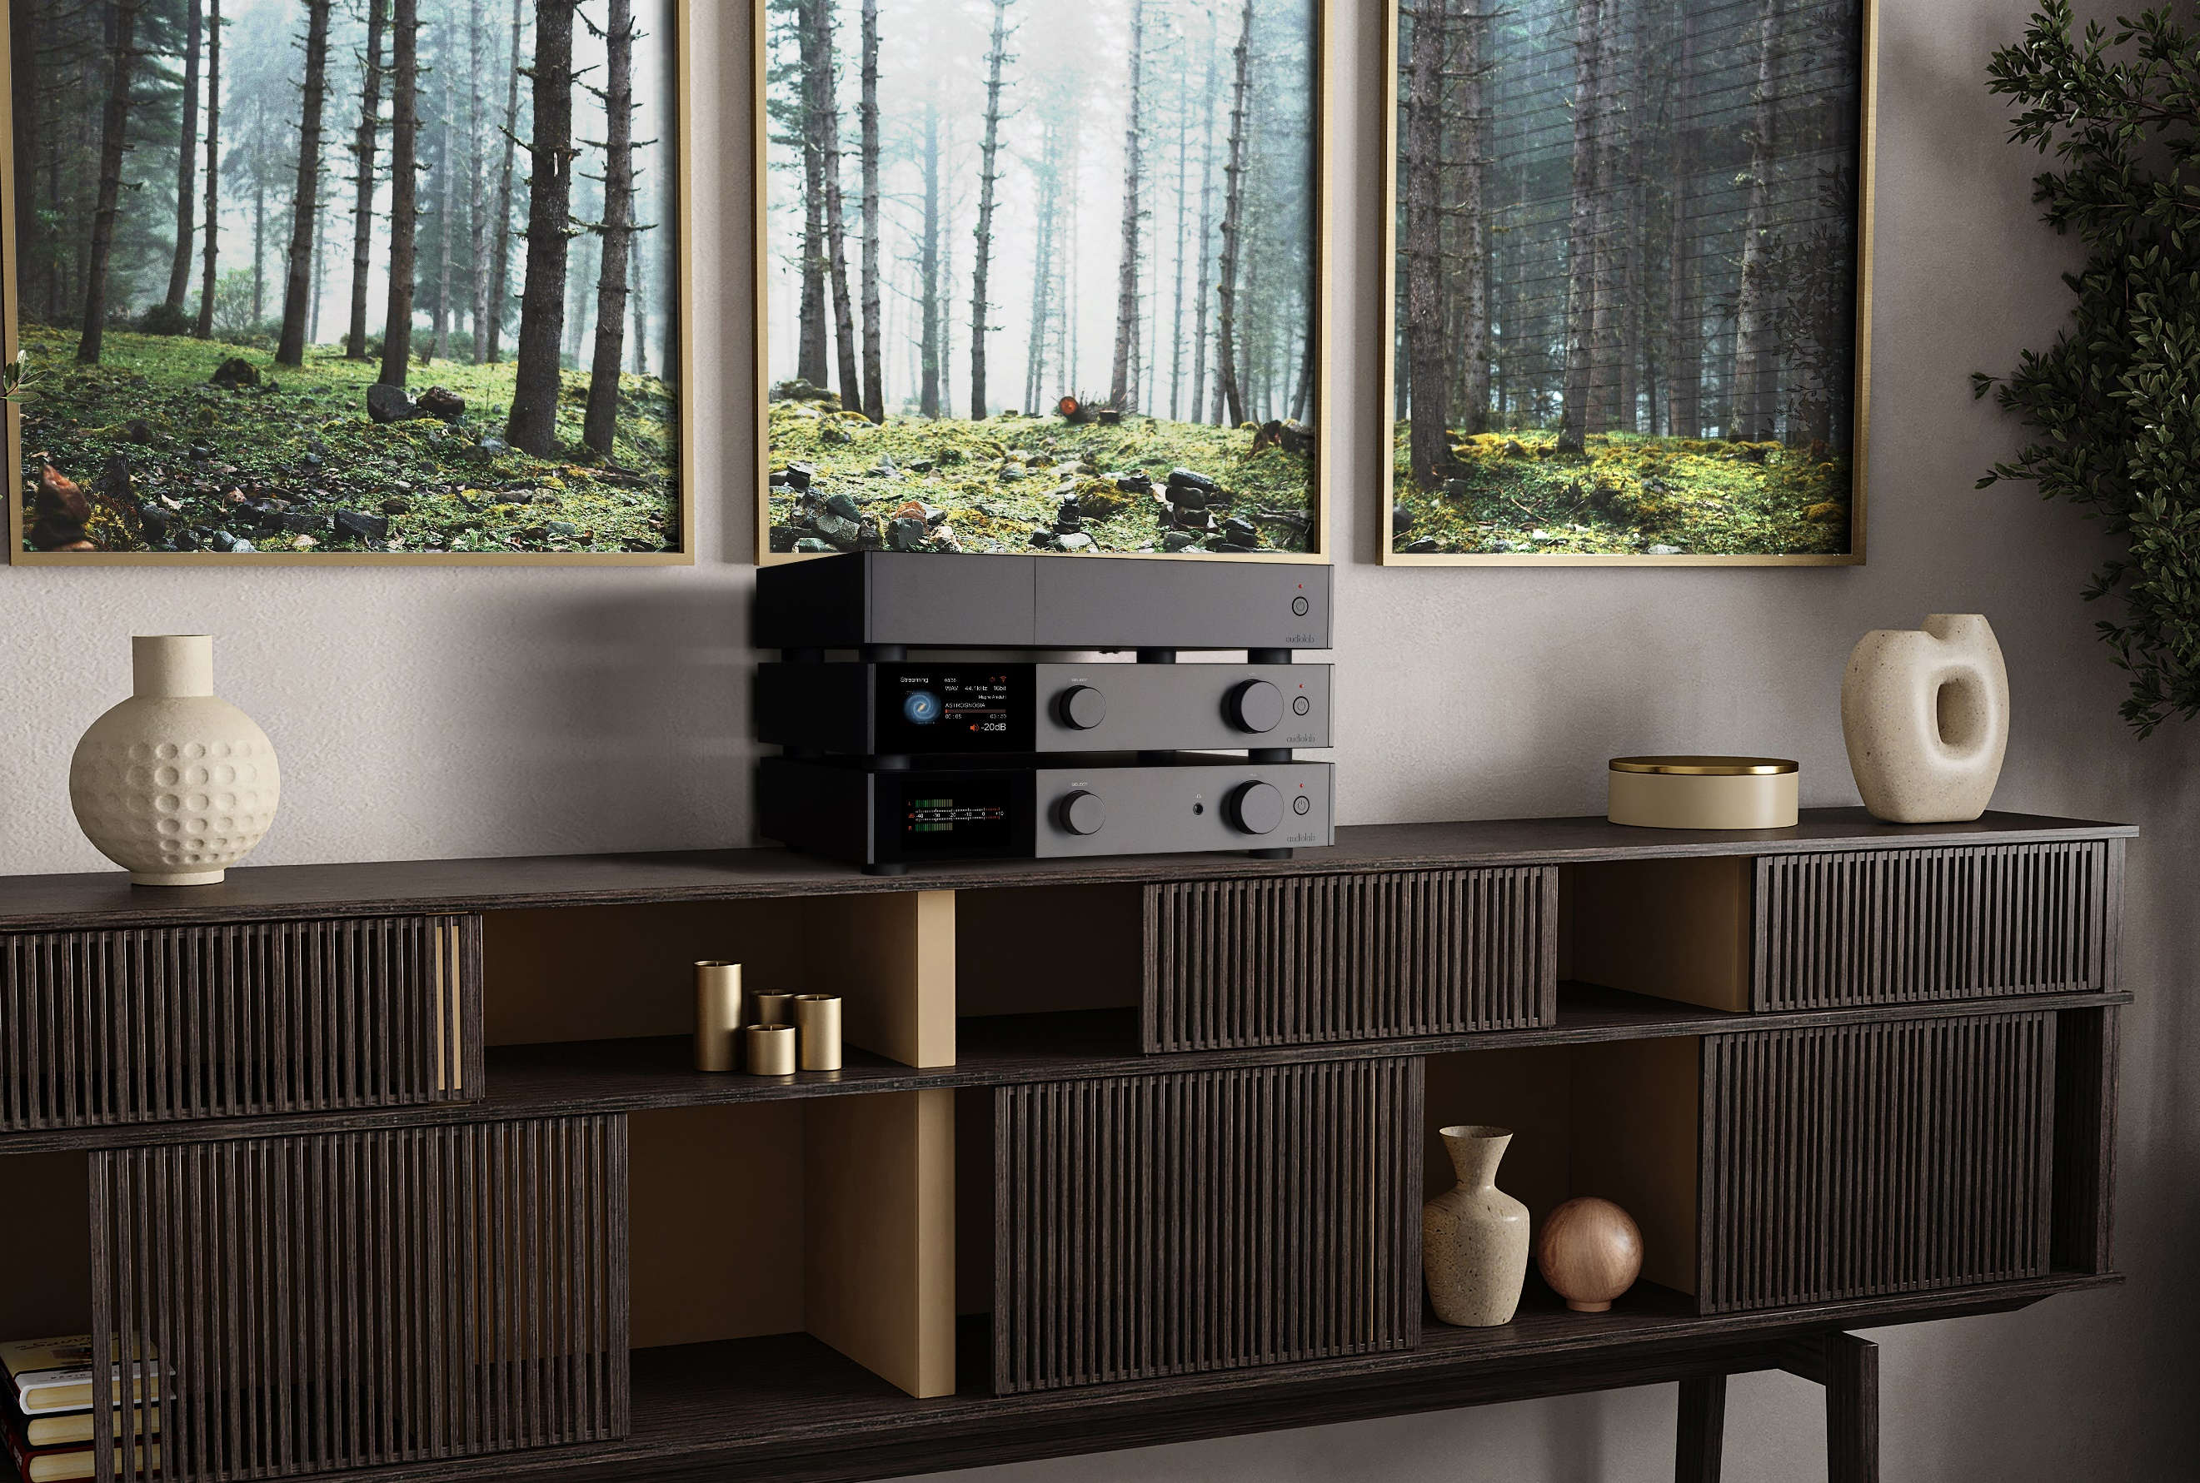

**High-End Audio that Shoots for the Stars but Doesn’t Cost the Earth**

The 9000Q and 9000P are the epitome of affordable high-end audio – build quality to be proud of, versatile functionality without a hint of compromise, and a performance that delivers every detail of the music and brings it to life in captivating style. They deliver remarkable sonic consistency across all manner of digital and analogue sources, always musically engaging yet also refined.

The soundstage they produce is broad and deep, with crisply defined detail revealing the full character of voices and instruments. Impressive dynamic range conveys natural impact, while the amps’ transient ability keeps feet tapping with rhythmic music. Deep, fleet-footed bass; expressive and expansive midrange; treble that sings with sweet precision – Audiolab’s flagship amp system delivers an adroitly balanced performance with all kinds of music, from rock and electronica to classical and jazz. In short, the 9000Q and 9000P deliver an open window on the music being played, as all great hi-fi should, engaging the listener with natural, unforced energy that is fully reflective of the source material.

**Availability and Pricing**

The Audiolab 9000Q preamplifier and 9000P stereo power amplifier are available from December in a choice of silver or black, at RRPs of $2,699.00 and $1,999.00 respectively. They will be sold exclusively in Canada through Erikson Consumer, and can currently be pre-ordered through your sales representative.

|  |  |
| --- | --- |
| AUDIOLAB 9000Q PREAMPLIFIER – SPECIFICATIONS SUMMARY | |
| Digital Inputs | 1x USB Type B; 2x coaxial; 2x optical; Bluetooth 5.1 |
| Analogue inputs | 1x stereo XLR; 3x stereo RCA line level; 1x stereo RCA phono (MM) |
| Analogue outputs | 1x stereo XLR; 2x stereo RCA; 1x stereo RCA fixed line-level; 1x headphone; 2x 12V trigger |
| DAC | ES9038PRO 32-bit DAC with Class A post-DAC active filter |
| Maximum digital sample rates | PCM 768KHz; DSD512 |
| Balanced analogue circuitry | Differential balanced topology; XLR Direct – fully balanced input to output |
| Sonic tuning options | Digital upsampling; 5x selectable digital filters; input-assignable analogue EQ |
| Colour display | 4.3in 800x480 IPS panel displaying versatile, graphically rich user interface |
| Dimensions (WxHxD) | 444x90x328mm |

|  |  |
| --- | --- |
| AUDIOLAB 9000P STEREO POWER AMPLIFIER – SPECIFICATIONS SUMMARY | |
| Amplifier type | Dual-mono Class AB with Complimentary Feedback design |
| Power output – stereo | 2x 100W (8 ohms, THD<1%); 2x 160W (4 ohms, THD<1%) |
| Power output – bridged (2x 9000P) | 2x 300W (8 ohms, THD<1%); 2x 380W (4 ohms, THD<1%) |
| Distortion (THD) | <0.002% (1kHz 8 ohms @ 2/3 max. Power) |
| Maximum current delivery | 2x 15A |
| Inputs | 1x stereo XLR; 1x stereo RCA; 1x 12V trigger |
| Outputs | 1x stereo speaker binding posts |
| Dimensions (WxHxD) | 444x90x328mm |

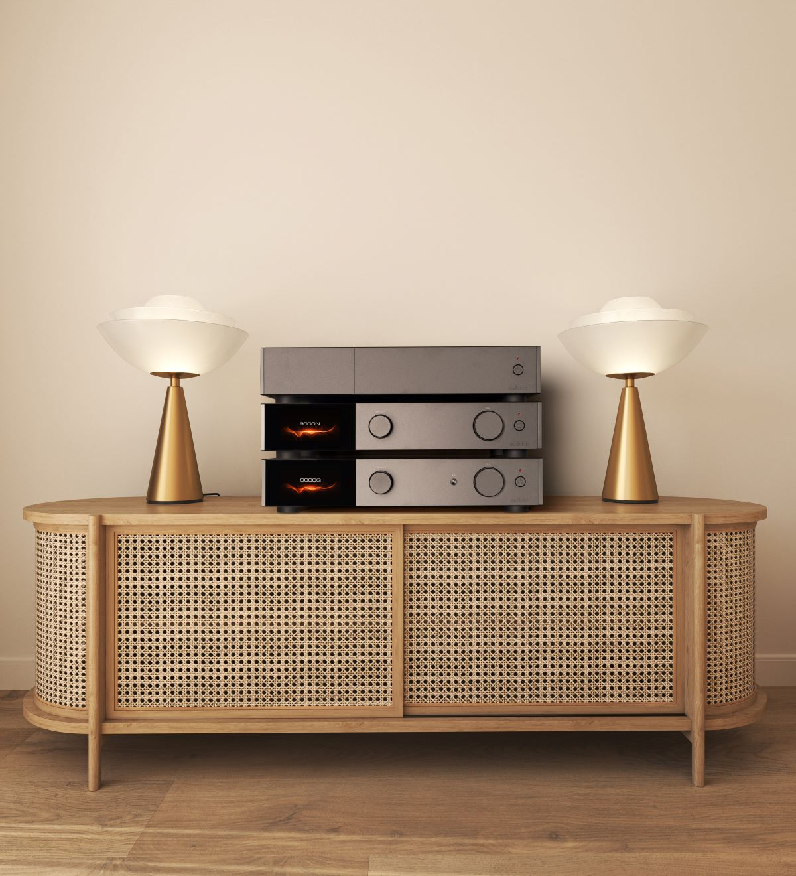

**About Audiolab**

Founded in 1983, Audiolab is a renowned British audio brand celebrated for its high-quality hi-fi components that combine technical innovation with elegant design. With a legacy rooted in delivering pure, immersive sound, Audiolab has established itself as a leader in audio excellence, catering to discerning audiophiles and music enthusiasts worldwide. Its award-winning product lineup spans amplifiers, DACs, CD players, and more, offering cutting-edge technology that bridges the gap between performance and usability. Audiolab remains committed to pushing the boundaries of home audio, delivering unparalleled listening experiences for modern music lovers.

**About Erikson Consumer**

Erikson Consumer, an Exertis | JAM business, is one of Canada’s largest independent distributors of audio & electronic solutions with a portfolio fortified by the industry’s most renowned brands of multimedia, luxury audio, home comfort and mobile audio products. Its product selection includes award-winning brands that can be found in all key national and regional chains, furniture/appliance and specialized independents. Erikson Consumer takes pride in offering clients product training from introductory to technical levels, supported by dedicated sales and marketing teams prepared to assist before and after sales, with stock readily available from a state-of-the-art 250,000 square foot warehouse facility.

With over fifty years of experience, Erikson Consumer has grown and diversified, providing the Canadian marketplace with a resourceful, reliable, and innovative distribution network.