**Erikson Consumer Appointed Exclusive Canadian Distributor for KLH Audio**

FOR IMMEDIATE RELEASE

Media contact:

Nataliya Potapova

[Nataliya.potapova@eriksonconsumer.com](mailto:Nataliya.potapova@eriksonconsumer.com)

Tel: +1 438 801 3818

**July 9th 2025, BAIE D’URFÉ** – Following Victrola's acquisition of KLH, Erikson Consumer expands premium audio offering with legendary speaker brand.

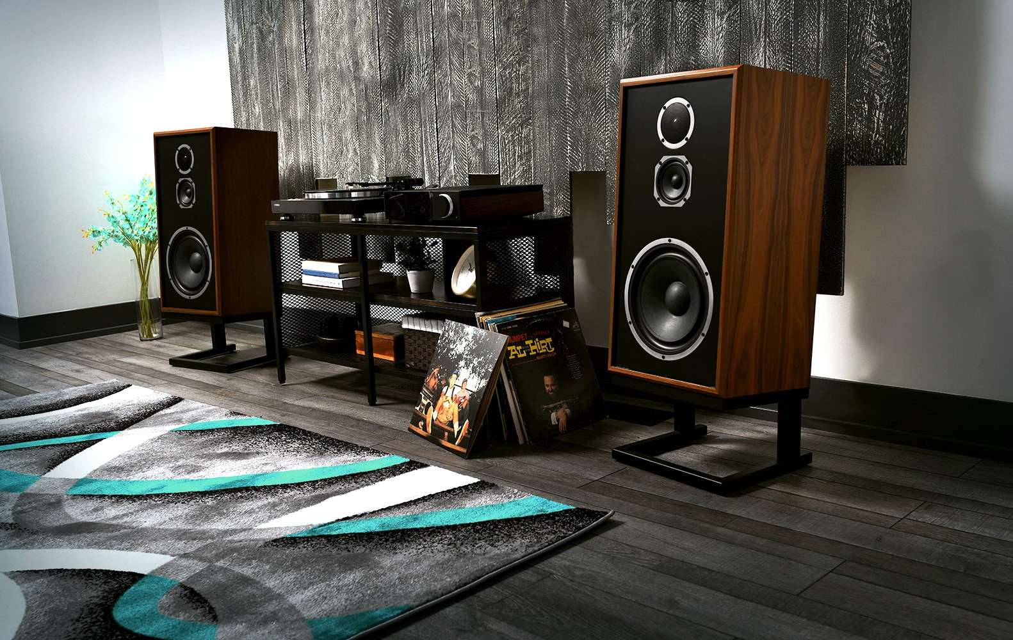

Erikson Consumer, one of Canada’s leading distributors of audio and electronics solutions, is pleased to announce a new partnership with KLH Audio, the iconic American loudspeaker manufacturer. Through this agreement, Erikson Consumer becomes the exclusive distributor of KLH products in Canada, further enhancing its growing portfolio of premium audio brands.

The announcement follows the recent acquisition of KLH by Victrola, another legacy audio brand exclusively distributed in Canada by Erikson Consumer. This alignment strengthens Erikson Consumer’s commitment to delivering exceptional sound experiences through brands that value both heritage and innovation.

Founded in 1957 by audio pioneer Henry Kloss, KLH has earned a reputation for producing industry-defining loudspeakers known for their fidelity, craftsmanship, and engineering excellence. From its early groundbreaking acoustic suspension designs to its current line of high-performance speakers, KLH continues to push the boundaries of home audio.

Today, KLH’s lineup includes standout products such as the **Model Five**, a three-way acoustic suspension speaker that pays tribute to its iconic predecessor while integrating modern materials and technology for today’s audiophile. The **Model Three**, a more compact but equally powerful bookshelf speaker, delivers stunning clarity and warmth, making it ideal for smaller spaces without sacrificing audio integrity. KLH also offers immersive home theatre solutions such as the **Kendall Series**, a full-range lineup of tower and bookshelf speakers known for their elegant real wood veneers and lifelike soundstage.

*“We’re proud to welcome KLH to the Erikson Consumer family,” said Bruno Gomes, Business Development Manager at Erikson Consumer. “KLH’s legacy of excellence and commitment to premium sound perfectly aligns with our mission to bring the best in high-fidelity audio to the Canadian market. With the strength of our national distribution network and our deep relationships with specialty and mainstream retailers, we’re excited to offer this iconic brand to music lovers across the country.”*

As KLH enters a new chapter under the Victrola umbrella, the brand remains focused on preserving its audiophile roots while appealing to a new generation of listeners through a balance of retro design and modern innovation.

*“We’re thrilled to partner with Erikson Consumer as we expand KLH’s footprint in the Canadian market,” said David P. Kelley, Brand President of KLH Audio. Erikson’s deep expertise and longstanding reputation in premium audio distribution make them the ideal partner to help us deliver KLH’s commitment to high-fidelity sound and timeless design to a broader audience. This partnership marks a key milestone in our global growth strategy, and we’re excited for what’s ahead.”*

Canadian dealers can now access the full line of KLH products directly through Erikson Consumer. Retailers interested in becoming authorized KLH dealers are encouraged to contact Erikson Consumer for more information.

**About KLH**

KLH Audio is a legendary name in high-fidelity sound, pioneering innovative loudspeaker technology since 1957. With a heritage of industry firsts, including groundbreaking acoustic suspension designs and collaborations with audio visionaries, KLH has shaped the evolution of premium sound. KLH remains dedicated to excellence, delivering superior audio experiences.

**About Erikson Consumer**

Erikson Consumer is one of Canada’s largest independent distributors of audio & electronic solutions with a portfolio fortified by the industry’s most renowned brands of multimedia, luxury audio, home comfort and mobile audio products. Its product selection includes award-winning brands that can be found in all key national and regional chains, furniture/appliance and specialized independents. Erikson Consumer takes pride in offering clients product training from introductory to technical levels, supported by dedicated sales and marketing teams prepared to assist before and after sales, with stock readily available from a state-of-the-art 250,000 square foot warehouse facility.

With over fifty years of experience, Erikson Consumer has grown and diversified, providing the Canadian marketplace with a resourceful, reliable, and innovative distribution network.