SPENDOR UNVEILS ENHANCED A-LINE SERIES: ELEVATING YOUR MUSICAL EXPERIENCE

FOR IMMEDIATE RELEASE
Media contact:
Nataliya Potapova
Nataliya.potapova@eriksonconsumer.com
Tel: +1 438 801 3818

March 19th 2025, BAIE D’URFÉ – Spendor Audio Systems, a distinguished name in high-fidelity loudspeaker design and manufacture, is excited to introduce the Mark 2 version of its critically acclaimed A-Line Series.
The new and refined A-Line continues Spendor's tradition of exceptional sound quality, now enhanced with refinements that elevate the listening experience. Combining the company’s signature craftsmanship with advanced engineering, the A-Line Mark 2 delivers the pure, immersive musical enjoyment that Spendor is renowned for.
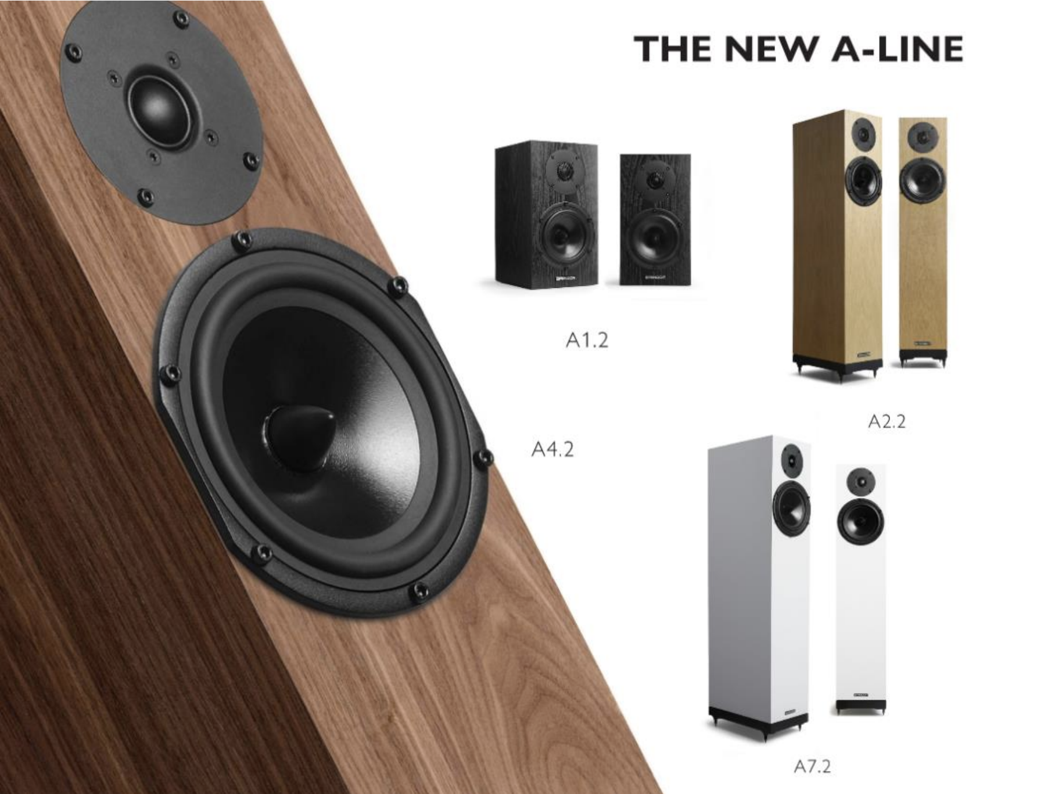
The updated and optimised A-Line series reaffirms Spendor’s dedication to true sound reproduction and unparalleled build quality.
Proudly designed, engineered, and manufactured in our state-of-the-art manufacturing facility on the outskirts of Sheffield, UK, the new A-Line series includes the A1.2, A2.2, A4.2, and A7.2 models.
Each speaker in the range has been thoughtfully upgraded to cater to the needs of both audiophiles and music lovers alike, offering a perfect balance between performance and value.

A1.2
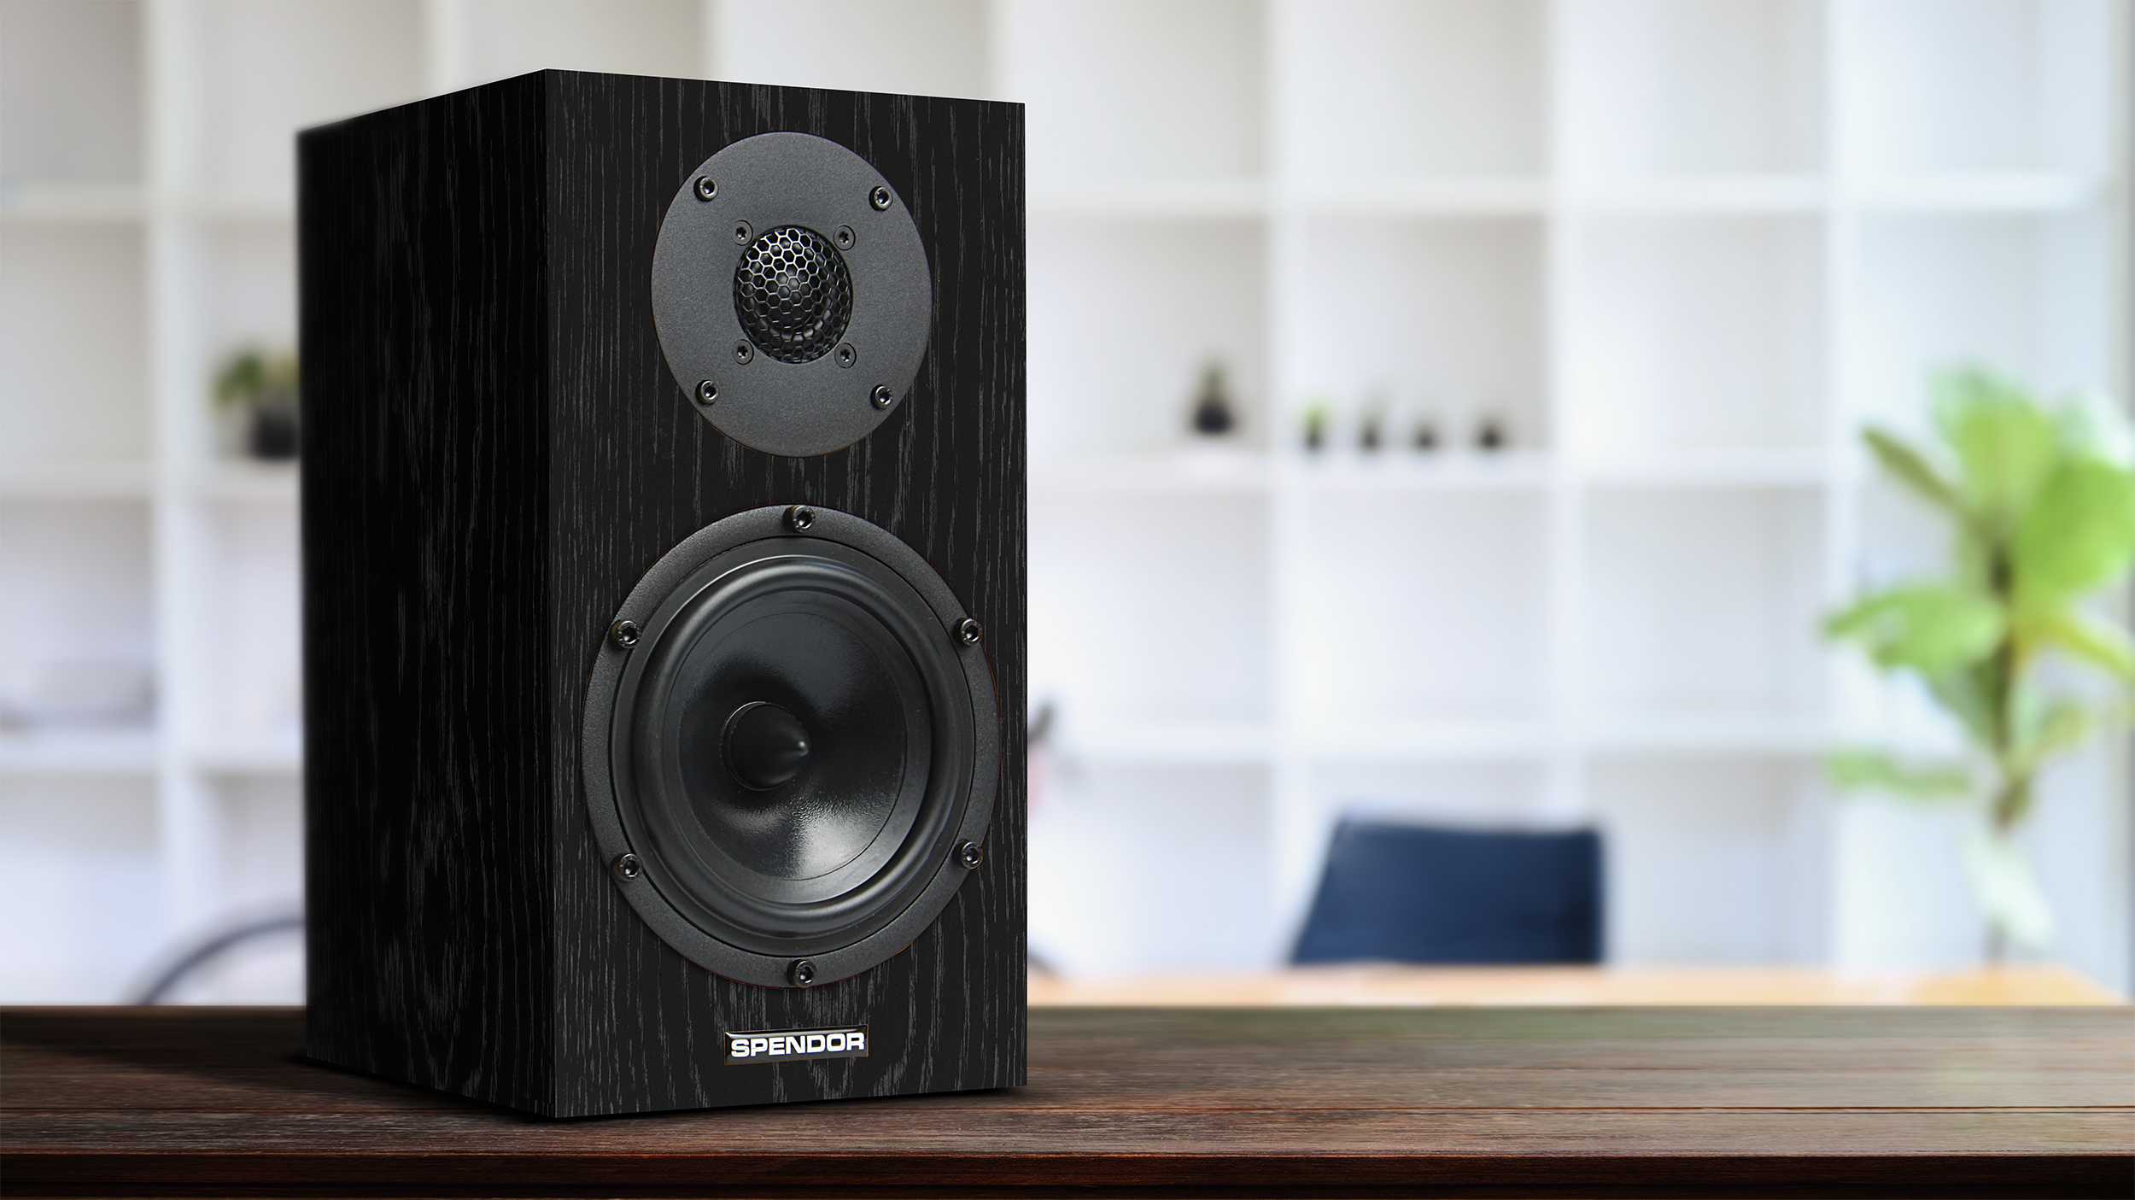
The A1.2, the most accessible model in Spendor’s new A-Line series, exemplifies our dedication to high-fidelity sound in a compact and affordable design.
With the Mark 2 version, we have introduced key advancements that preserve the essence of its predecessor while elevating its performance.
Innovative Internal Bracing and Constrained Damping for Purity of Sound
Central to the A1.2’s improvements is a refined internal bracing system. By repositioning the bracing directly behind the driver and incorporating a constrained damping layer of Sorbothane, we've minimised unwanted vibrations that can colour the sound. This design effectively absorbs vibrations from the driver, reducing cabinet interaction, minimizing time smearing, and lowering the noise floor.
The Result: Enhanced Clarity and Stereo Imaging
These enhancements result in cleaner, more precise sound with greater clarity in instruments and vocals. The improved bracing also enhances stereo imaging, delivering a more immersive listening experience with accurate soundstage placement.
The A1.2 doesn’t just honour the legacy of the A-Line; redefines expectations of what a compact bookshelf loudspeaker can achieve.
Whether in a high-end setup or a modest system, the A1.2 offers exceptional performance that will impress all who listen.

A2.2
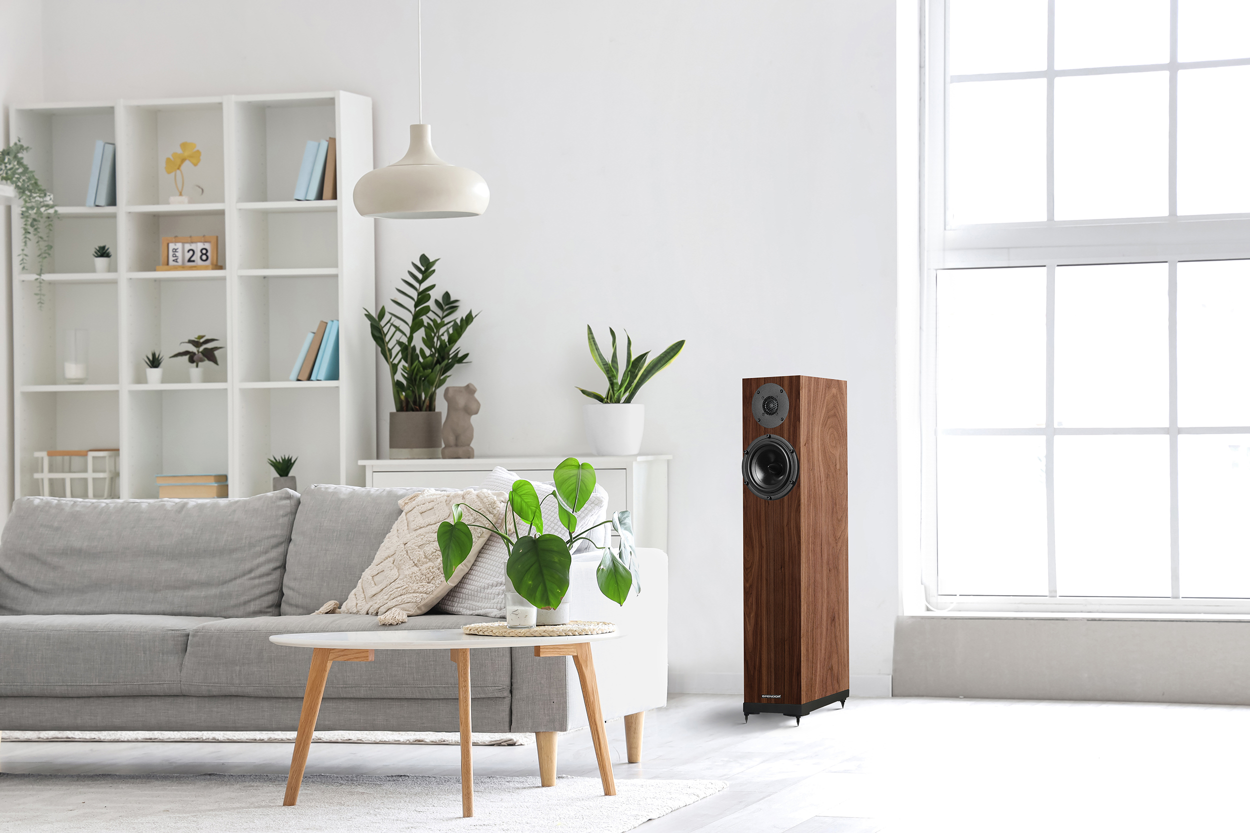
The A2.2 builds on the original A2, incorporating key innovations that elevate its performance while staying true to Spendor’s legacy of exceptional sound quality.
Constrained Damping for Enhanced Clarity
A standout feature of the A2.2 is constrained damping layer of Sorbothane, designed to eliminate unwanted vibrations between the driver and the enclosure boundary. Through this integration, we ensure that vibrations are effectively absorbed, resulting in a purer and more accurate sound.
This innovation significantly reduces colouration and distortion, delivering a clearer and more natural listening experience with improved stereo imaging.
Refined Port Tuning for Precise Bass Response
The A2.2 also features a refinement to the port tuning, addressing issues of timing and accuracy. Our engineers have meticulously tuned the port to produce tighter, more well-defined bass that complements the midrange and treble frequencies. The result is a balanced and cohesive sound that enhances the overall musical experience.
Enhanced Internal Bracing for Acoustic Purity
Significant enhancements have been made to the A2.2’s internal architecture, particularly in its bracing. The restructured bracing strengthens the cabinet and minimises unwanted resonances that can colour the sound. An improved airflow within the cabinet ensures consistent acoustic performance, allowing the A2.2 to deliver a cleaner and more precise sound.
The Result: A Loudspeaker That Exceeds Expectations
With these thoughtfully implemented improvements, the A2.2 embodies Spendor’s commitment to advancing loudspeaker design while remaining accessible to a broad audience.
The dynamic damping, refined port tuning, and enhanced internal bracing combine to create a loudspeaker that delivers a clearer, more musical sound, exceeding expectations at every level.
The Spendor A2.2 is more than just an upgrade; it’s a sophisticated audio experience designed to elevate your listening pleasure.
A4.2
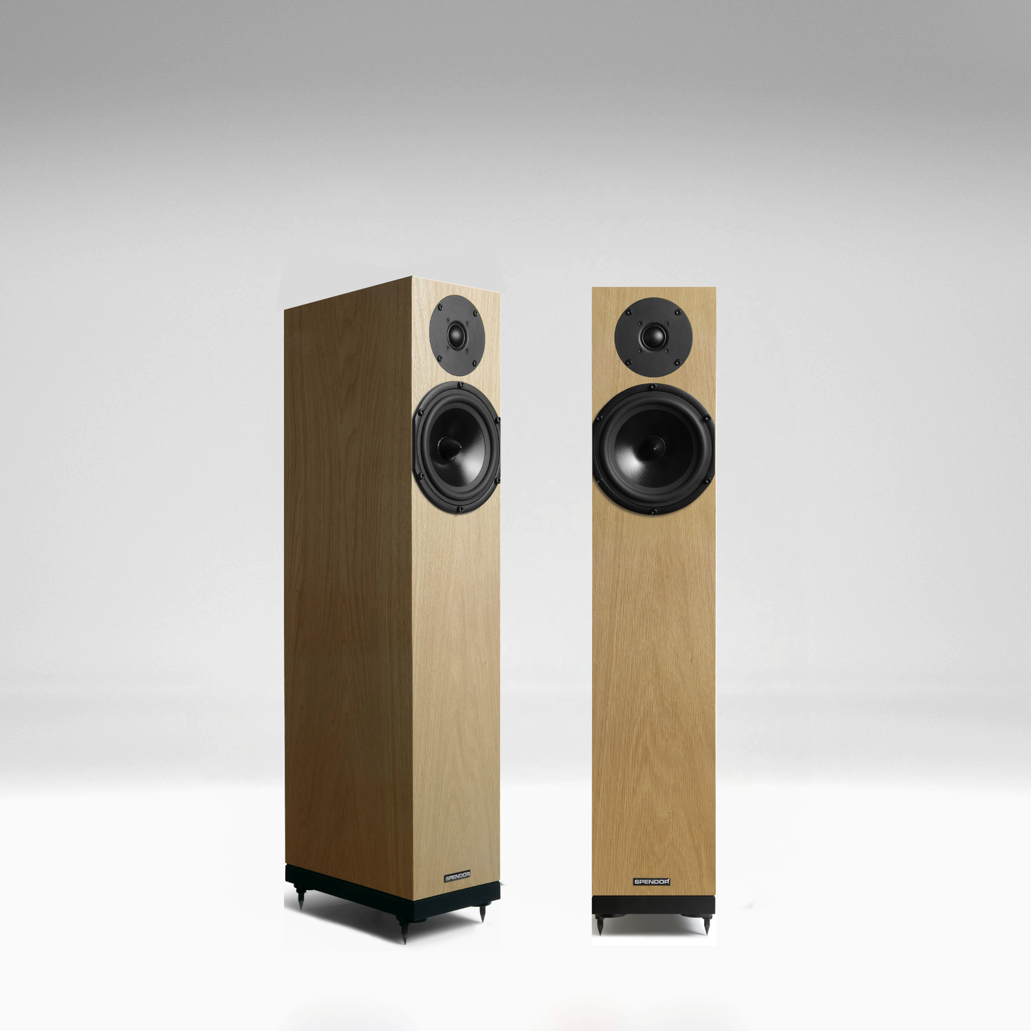
The A4.2 represents a refined iteration of our beloved, and classic, A4 model, embodying our commitment to continuous improvement and precision engineering. Our new model enhances the qualities that made the A4 one of our most popular loudspeakers, offering an even more engaging listening experience.
Constrained Damping: Enhanced Clarity
The A4.2 features an innovative damping system containing Sorbothane that significantly reduces unwanted vibrations, ensuring cleaner, more accurate sound. A specially selected damping material is strategically placed between the driver and the enclosure boundary to absorb vibrational energy, from the chassis and magnet assembly which stops it reradiating back into the cone and cabinet maintaining sound purity. Through extensive testing, we've achieved a more precise audio reproduction.
Refined Bass Response
We've meticulously fine-tuned the port design in the A4.2 to improve bass response, addressing common issues like port compression and timing inaccuracies. The result is less transient smearing and a tight, controlled bass, delivering a balanced and involving listening experience.
Upgraded Internal Bracing
The A4.2 benefits from enhanced restructured internal bracing, which strengthens the cabinet and optimises airflow around the cabinet enclosure. This improvement reduces resonances, leading to a more stable soundstage and a purer, more focused musical output.
Crossover Refinements: Seamless Integration
The crossover network in the A4.2 has been redefined to enhance driver integration and overall performance. By simplifying the network and lowering the crossover point, we've achieved a more coherent and natural sound with improved stereo imaging and smoother off-axis response. These adjustments also make the A4.2 more amplifier friendly, accommodating a wider range of amplifiers.
Redesigned Spider: Precision Timing
The redesigned spider in the A4.2's driver enhances timing and transient response, allowing the speaker to handle complex musical passages with greater precision. This results in more articulate and detailed sound reproduction, particularly in fast-paced music.
New Tweeter and Refined Mid-Woofer: Dynamic High-Frequency Performance
The A4.2 introduces a brand-new soft dome wide surround rear-chambered 27mm tweeter designed to deliver a more open, dynamic, and natural high-frequency response. With an extended frequency range and improved transition between midrange and highs, this tweeter enhances clarity and accuracy, offering a more immersive listening experience.
The A4.2 is a finely tuned loudspeaker that brings your music to life with remarkable fidelity and emotion. Each enhancement has been carefully engineered to exceed the expectations of discerning audiophiles, staying true to Spendor's legacy of engaging and immersive sound.

A7.2
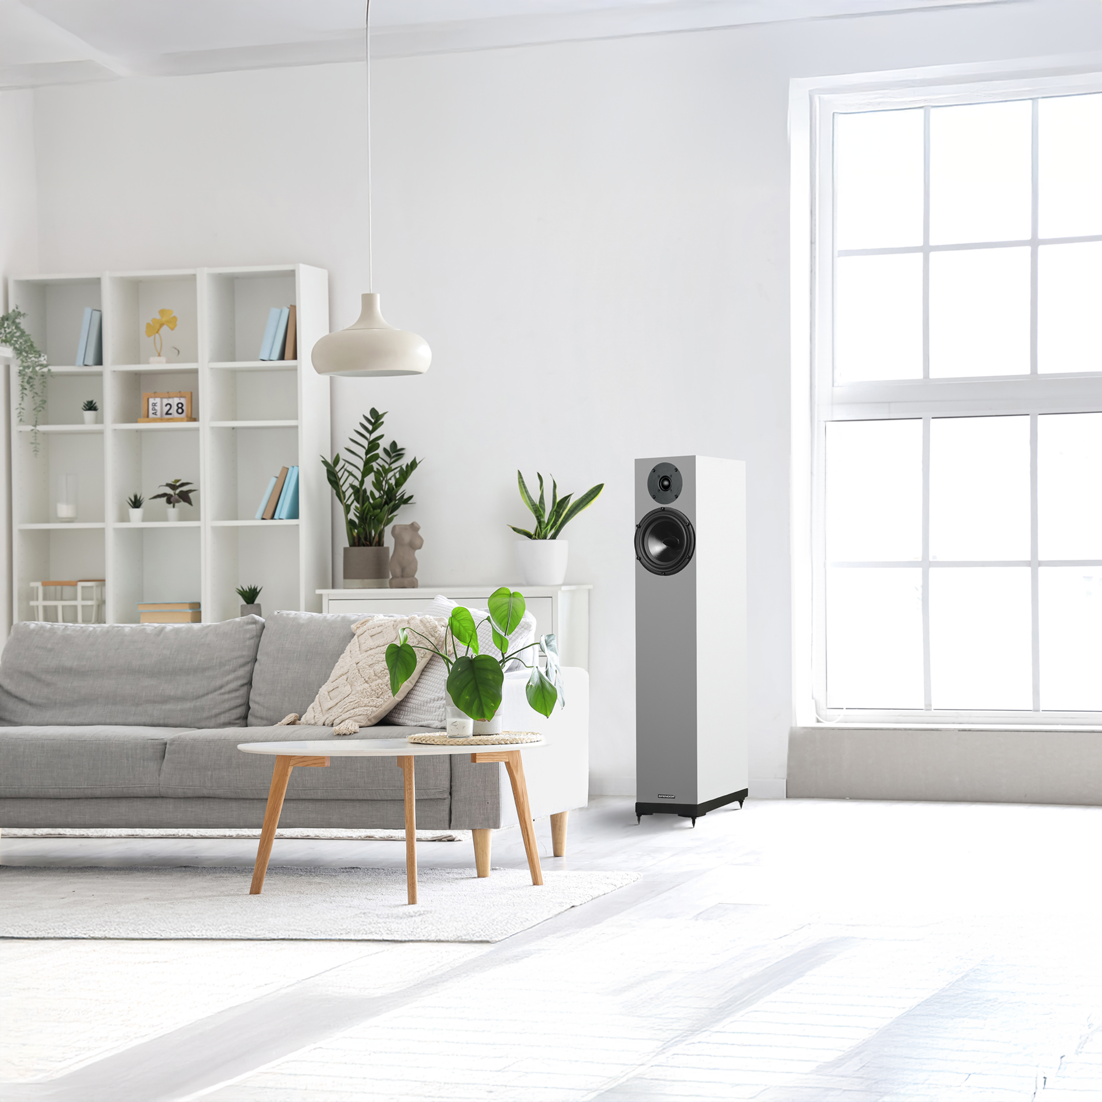
Spendor is excited to unveil the A7.2, the latest generation of our critically acclaimed A7 loudspeaker. Building on its predecessor’s performance and success, the A7.2 features key upgrades designed to enhance your audio experience, reflecting Spendor’s dedication to sonic excellence.
Enhanced Port Tuning for Precise Bass
The A7.2 boasts a re-engineered port design, positioned closer to the driver to shorten the path length to minimise any pipe-resonances up in the frequency band and no midband interference. This results in more accurate and controlled bass, as the port now directly channels rear energy from the cone, improving frequency and phase response for richer low frequencies.
Optimised Internal Bracing for Improved Stability
With restructured internal bracing featuring Sorbothane, the A7.2’s cabinet is reinforced, reducing unwanted resonances and allowing better airflow. This design minimises cabinet modes and vibrations, leading to clearer mid and upper frequencies.
Refined Crossover for Seamless Driver Integration
The A7.2 features a refined crossover for a more cohesive soundstage. Adjustments to the crossover point achieve a flatter off-axis response and a smoother roll off as well as enhancing stereo imaging and providing a cleaner more precise sound. This results in a well-balanced, natural and open sound with improved phase coherence.
Advanced Spider Design for Superior Articulation
A redesigned spider improves cone control for better timing and transient response. This advancement allows the A7.2 to reproduce intricate details with greater precision, delivering a more dynamic and engaging listening experience.
A Refined Mid-Woofer and New Tweeter for Crisp High Frequencies
The A7.2’s new soft dome wide surround rear-chambered 27mm tweeter offers enhanced highfrequency performance. With a lower crossover frequency, it provides a broader frequency range and better coherence. The results are crisp, detailed highs that integrate seamlessly with the rest of the audio spectrum.
We’ve refined our optimally matched woofer via adjustments to its suspension to create minimised transient ringing and a more balanced, and well-timed response.
Each enhancement contributes to a more refined, immersive listening experience, perfect for audiophiles and music lovers seeking unparalleled sound quality. Spendor continues to build on the A7’s legacy, combining craftsmanship with cutting-edge engineering.

Designers Notes
We are excited to introduce the latest evolution of the A-Line loudspeakers—a refined series that embodies precision, passion, and a commitment to excellence.
The design team at Spendor have dedicated countless hours to immersing ourselves in every detail of the A-Line, from extensive listening sessions to meticulous measurements and hands-on experimentation. This deep engagement with the A-Line has provided us with unique insights into what makes these speakers truly exceptional.
The A-Line has consistently been celebrated for its outstanding performance, earning worldwide critical acclaim. Our mission with this latest iteration was straightforward: to enhance its already legendary qualities while addressing its imperfections.
Rather than completely redesigning the product, we chose to focus on perfecting the existing A-Line, ensuring that it continues to capture the core magic that has made it a favourite among audiophiles and music lovers alike.
This refined version represents a thoughtful and honest evolution, one that maintains the charm of its predecessor while delivering an even greater performance. The new A-Line is the culmination of our efforts to create a more technically sound and ultimately more musical loudspeaker range.
By focusing on the key fundamentals, we have been able to fully optimise what we already have, whilst maintaining manufacturing efficiency. The result is a cornerstone for future products, where a ground-up approach will be implemented.
Availability and Pricing
Pre-orders for the new A-Line have already begun before and after its highly anticipated world debut at the Bristol Hi-Fi Show on Friday 21st February 2025. Shipping will begin in Spring 2025. Contact your Erikson Consumer Representative for more information, and to pre-order today!
The new A-Line range comes in a variety of elegant finishes, including Oak, Walnut, Black Oak, and Satin White veneer, allowing you to choose the perfect match for your listening space.
Canadian Pricing:
- A1.2: $3,000.00 per pair
- A2.2: $2,000.00 per pair
- A4.2: $3,000.00 per pair
- A7.2: $4,000.00 per pair

About Spendor
At Spendor, we design, engineer, and manufacture all our loudspeakers in our state-of-the-art manufacturing facility in South Yorkshire, UK. Every Spendor loudspeaker is meticulously assembled where we refine components and cabinets through our dedicated in-house R&D program.
Our loudspeakers are designed for effortless setup and compatibility with any Hi-Fi or Home Theatre system, enhancing the way you experience all types of music and soundtracks. With a timeless, elegant design honed over five decades, they seamlessly integrate into any room while delivering a sound quality that far exceeds their price point.
Founded in the late 1960s by Spencer and Dorothy Hughes—whose names inspired 'Spen' and 'Dor'—Spendor began with Spencer’s engineering expertise from the BBC’s sound department. His pioneering design, the BC1, quickly became the preferred monitor for broadcasters and recording studios worldwide.
More than 50 years later, the legacy of the BC1 and its successors continues to shape our distinctive, innovative loudspeakers. Spendor remains a reference standard for audiophiles and professional sound engineers, renowned for delivering a transparent, natural, and captivating sound experience.

About Erikson Consumer
Erikson Consumer, an Exertis | JAM business, is one of Canada’s largest independent distributors of audio & electronic solutions with a portfolio fortified by the industry’s most renowned brands of multimedia, luxury audio, home comfort and mobile audio products. Its product selection includes award-winning brands that can be found in all key national and regional chains, furniture/appliance and specialized independents. Erikson Consumer takes pride in offering clients product training from introductory to technical levels, supported by dedicated sales and marketing teams prepared to assist before and after sales, with stock readily available from a state-of-the-art 250,000 square foot warehouse facility.
With over fifty years of experience, Erikson Consumer has grown and diversified, providing the Canadian marketplace with a resourceful, reliable, and innovative distribution network.

