Erikson Multimedia wins Best Buy Specialized Partner of the Year Award

FOR IMMEDIATE RELEASE
Media contact:
Nataliya Potapova
nataliya.potapova@eriksonconsumer.com
Tel: + 1 438 801 3818

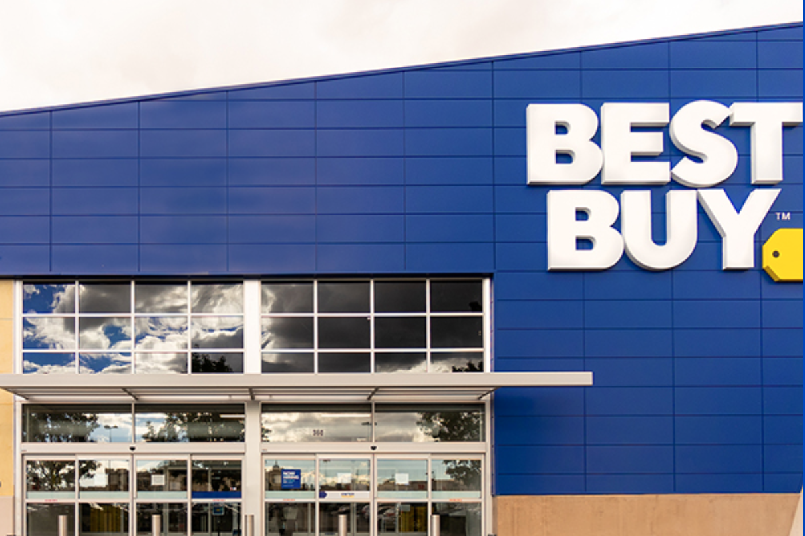

John Thomson, WifiHifi March 2023 – Erikson Multimedia, an Exertis | JAM business, has recently won Best Buy Canada’s Specialized Partner of the Year Award for its work in the consumer audio space via its distributed brand JBL Audio. “This win is a testament to their ongoing excellence in the consumer electronics distribution industry and to the hard work and dedication of the Erikson team, whose ability to go above and beyond has positioned our group for this honor and future success” stated Best Buy.
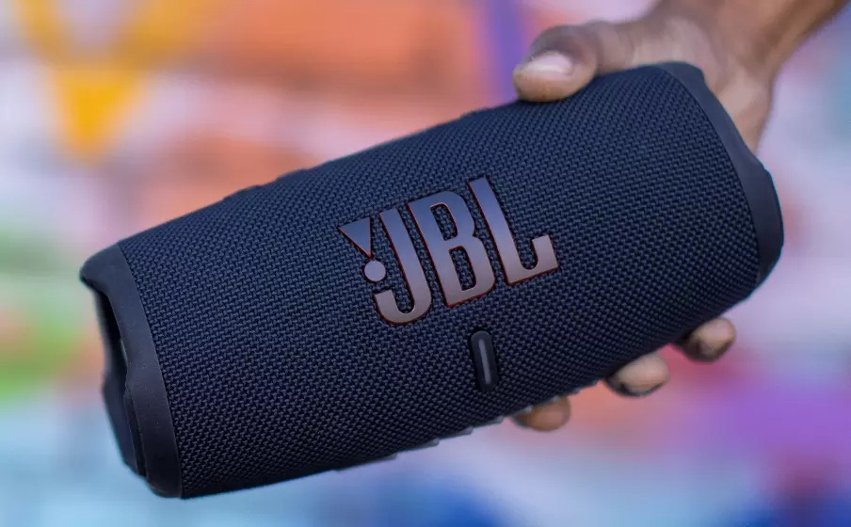

About Erikson Multimedia
Erikson Multimedia is the Consumer Electronics division of Exertis | JAM and distributes high-performance consumer products from brands including Adidas, Harman Kardon, JBL, Marshall, Urbanista, and more.

Erikson Multimedia
21000 TransCanada Highway
Baie D’Urfé, QC H9X 4B7
Phone: 514-457-2555 / Fax: 514-457-0055
http://www.eriksonconsumer.com

