Erikson Multimedia Announces Exclusive Distribution Partnership with Austere

FOR IMMEDIATE RELEASE
Media contact:
Nataliya Potapova
nataliya.potapova@eriksonconsumer.com
Tel: + 1 438 801 3818

BAIE D’URFÉ, QC, DECEMBER 15, 2022 – Erikson Multimedia, an Exertis | JAM business, is pleased to announce partnership with Austere, a unique technology accessories brand. Under the agreement, Erikson Multimedia will be the exclusive distributor in Canada for all Austere products.
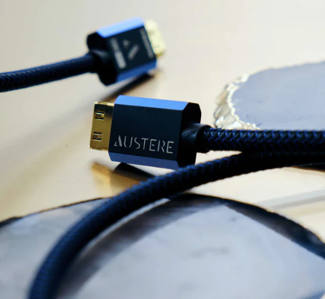

“Austere’s line of future ready and technologically superior products is both a welcome and natural addition to our portfolio of high-performance consumer products,” says Jocelyn Rowcliffe, Director of Merchandising at Erikson Multimedia. “Their technology accessories provide outstanding synergy with our existing catalogue, and as a result this exciting partnership will lead to a great future for all parties involved.”

“We are thrilled to partner with Erikson Multimedia,” says Deena Ghazarian, CEO of Austere. “Their long-standing reputation as leaders in the distribution of high-performance consumer electronics is a perfect match for our established brand of exceptional technology accessories. Together, we will significantly accelerate Austere’s growth throughout Canada.”

Austere products are available in Canada at all major retailers now.

About Austere
Launched in 2019, Austere is a unique technology accessory brand committed to spectacularly designed, technologically superior products to power and connect your life. From high-performance power, cable, and clean products, Austere represents the intersection of flawless, minimalist design and advanced technology to redefine technology accessories. Austere stands apart from all other technology accessories manufacturers for its commitment to designing a new generation of products that offer consumers more stylish, sustainable, and better ways to connect both with their electronic devices and each other.
austere.com

About Erikson Multimedia
Erikson Multimedia is the Consumer Electronics division of Exertis | JAM and distributes high-performance consumer products from brands including Adidas, Harman Kardon, JBL, Marshall, Urbanista, and more.

Erikson Multimedia
21000 TransCanada Highway
Baie D’Urfé, QC H9X 4B7
Phone: 514-457-2555 / Fax: 514-457-0055
http://www.eriksonconsumer.com

