Erikson Consumer – Multimedia Division Announces Latest JBL Wi-Fi Speaker Range – JBL Authentics

FOR IMMEDIATE RELEASE
Media contact:
Nataliya Potapova
Nataliya.potapova@eriksonconsumer.com
Tel: +1 438 801 3818

BAIE D’URFÉ, QC, SEPTEMBER 1, 2023 – Erikson Consumer – Multimedia Division, an Exertis | JAM business, is excited to announce JBL’s newest Wi-Fi speaker range, JBL Authentics!

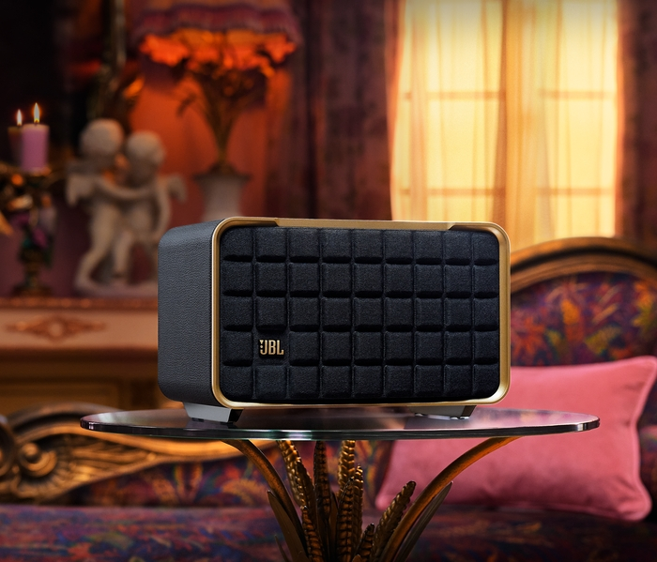

Unveiling the JBL Authentics series, JBL brings together timeless retro aesthetics and a variety of features. This exceptional lineup pays homage to JBL's legacy, fusing iconic design with cutting-edge technology. The centerpiece of this range, the JBL Authentics 500, is a home audio masterpiece, boasting both Wi-Fi and Bluetooth connectivity to deliver an enveloping Dolby Atmos® experience. The series also includes the JBL Authentics 200 and the portable JBL Authentics 300, offering versatility and premium sound quality.

Inspired by the legendary 1970s JBL L100 speaker, the JBL Authentics series combines iconic retro design elements with modern sophistication. These speakers surely cannot be overlooked, crafted with a premium aluminum frame, a custom synthetic leather-wrapped enclosure, and a reimagined Quadrex grille.

A Model Fit for Any Home

Immerse yourself in music like never before with the JBL Authentics 500. This audio marvel boasts three 1” tweeters and three 2.75” midrange woofers for pristine sound, while a 6.5” downfiring subwoofer ensures precise, deep bass. With a powerful 270 Watts of 3.1 channel sound and Dolby Atmos technology, you'll be able to experience unbelievable sound quality and precision, all from the comfort of your home.

For those seeking superior sound quality with a portable option, the JBL Authentics 300 comes equipped with an 8-hour built-in battery. While being able to take the speaker in and around your home, whether you’re indoors or outdoors, you’ll be able to experience exceptional audio performance, crisp highs, and rich bass.

The JBL Authentics 200 will also fill any room with high quality stereo sound. With a pair of 1” tweeters, a full-range 5” woofer, and a downfiring 6” passive radiator, this speaker is equipped for vibrant highs and deep balanced bass, creating the perfect listening experience no matter what kind of song you play.

Wi-Fi Features, Integrations, and Streaming Options

With the Authentics Series, JBL announces a new integration alongside Amazon and Google in which users will be able to simultaneously use both Alexa and Google Assistant on the same device. This collaboration will bring a new level of unprecedented flexibility to JBL customers, allowing them to seamlessly speak to both assistants and take advantage of their varying features and abilities in different situations. Once set up through the JBL One app, you can effortlessly use voice commands to play music, control smart home devices, set timers, and more.

The benefits of the Authentics series Wi-Fi connection is further exemplified through its streaming options, including AirPlay, Alexa Multi-Room Music (MRM), Spotify Connect, and Chromecast built-in™.

Distribution around your home

You can easily distribute music throughout your home by placing multiple JBL Authentics speakers in different rooms or connecting them to play the same playlist. As soon as you power on your JBL Authentics speaker, maintaining optimal sound quality is made easy with automatic self-tuning, which ensures that the sound quality of your speaker is consistently exceptional and adapted to it’s surroundings, regardless of it’s placement.

Seamless Setup and Personalization

Setting up the JBL Authentics speakers is a breeze with the JBL One app, which also provides access to integrated music services, allowing you to discover new tracks and artists. Tailor your listening experience with the app's customizable EQ settings.

Eco-Friendly Design

JBL is committed to sustainability. The Authentics speakers are made from 100% recycled fabric, 85% recycled plastic, and 50% recycled aluminum.

--------

JBL Authentics will be available and shipping from Erikson Consumer’s Montreal headquarters in October at MAP $499.98 for Authentics 200, MAP $649.98 for Authentics 300, and MAP $999.98 for Authentics 500. Please reach out to Erikson Consumer for more information at info@eriksonconsumer.com.

About JBL
For over 75 years, JBL has shaped life’s most memorable moments at the intersection of music, lifestyle, gaming and sports. JBL elevates listening experiences with superior audio quality and product designs that encourage individuality and self-expression. With unmatched professional credentials and industry-leading innovation, JBL is a trailblazer in the audio industry because of passionate and talented engineers and designers around the globe. JBL Pro Sound is the foremost technology pushing culture forward through major pop culture events and partnerships with the world’s top talent across music, sports and esports.

About Erikson Consumer, Multimedia Division
Erikson Consumer, Multimedia Division is the Consumer Electronics division of Exertis | JAM and distributes high-performance consumer products from brands including Harman Kardon, JBL, Marshall, Adidas, Urbanista, and more.

About Erikson Consumer
Erikson Consumer is one of Canada’s largest independent distributors of audio solutions, offering a diverse portfolio including the industry’s most renowned brands for Home, Mobile, and Multimedia markets. Erikson Consumer is one of the most trusted partners in the Consumer Electronics category.

