Erikson Consumer Hosts “Elevate and Innovate” Dealer Show in Toronto

FOR IMMEDIATE RELEASE
Media contact:
Nataliya Potapova
Nataliya.potapova@eriksonconsumer.com
Tel: +1 438 801 3818

JOHN THOMSON, WIFIHIFI, FEBRUARY 2024 – The contemporary Arta Gallery in the trendy Distillery District of Toronto was the location for Erikson Consumer's dealer show last week, highlighting new product releases for home, mobile and multimedia.

The theme of this year’s show was “Elevate and Innovate” with innovation coming from new releases from Erikson Consumer brands such as JBL, Arcam, Austere, Marshall and Jewel while the elevation came from the meticulous displays and branding that Erikson created inside the art gallery to fully represent the DNA and mission of each brand the distributor carries. A total of 20 brands were represented, each with artistic displays with many of the brand founders and executives on-site, to represent their products. The idea of elevating through beautiful visual displays aligned cleverly with the aesthetics of the Arta Gallery backdrop.
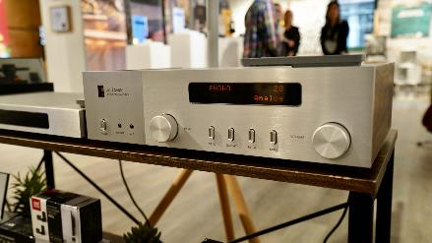

The fully catered event welcomed approximately 80 guests and dealers from across Canada with a corporate Erikson “blue” Consumer mocktail, a symbol representing unification among the mobile, multimedia and home categories that operate inside the Erikson Consumer banner.

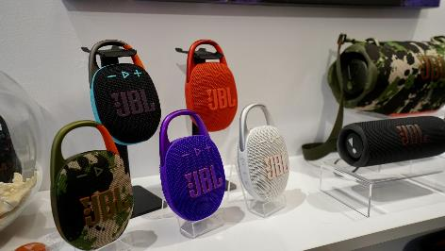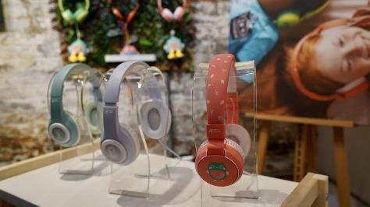

Dealers were able to see recently announced new products such as the JBL Clip 5, the updated JBL Go 4, and the latest Xtreme 4 firsthand, as well as seeing completely the redesigned Arcam integrated amps. While Erikson Consumer has a long history with the Harman Group of Companies that include the brands JBL, Harman, Revel and Arcam, the Elevate and Innovate dealer show also displayed new releases from brands such as Cyrus and Spendor that are newer additions to the Erikson Consumer portfolio.

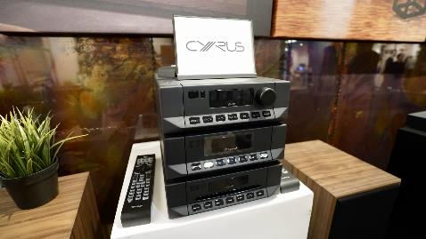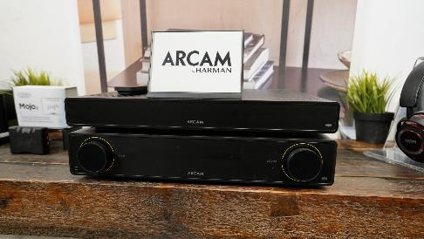

Another new brand for Erikson is Ultrahuman, a smart device company that captures sleep patterns, heart rate, steps and fitness activity through a ring on one’s finger rather than what’s usually captured via a smart watch. A six hour battery life in the ring provides close to a week’s worth of analytical data with very little intrusion to the ring’s wearer.
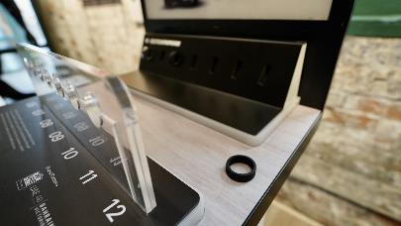

The JBL car division showed sound bars designed for ATVs and recreational vehicles, a sleeper category that has exploded in the past three years that also includes sound systems for golf carts with soundbars.

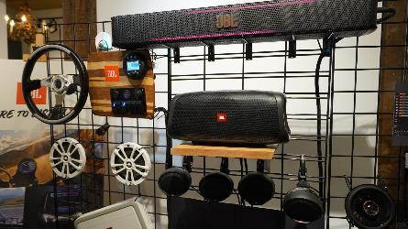

Swedish brand Marshall, as always, brought a rock ‘n roll edge to the show highlighting new releases and upgrades to the brand’s growing sku of portable Bluetooth speakers and headphones.

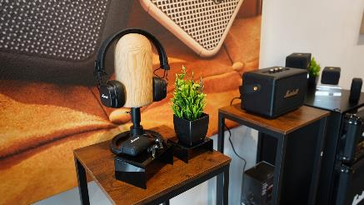

Cable and accessory brand Austere reminded us that no small detail can be overlooked when creating the perfect HDMI cable where every colour inlay and braid has been purposely engineered to offer a product that looks as great as it performs.

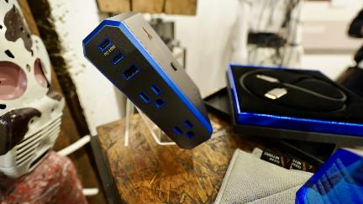
While it has been said so many times, in a time when a quick Google search can yield a picture or answer to almost any question, no online experience can come even close to the reward of an in-person event. Erikson Consumer indeed elevated the worthy experience by picking a beautiful gallery to host their dealer event while highlighting innovative new product releases in a curated way.

About Erikson Consumer
Erikson Consumer is one of Canada’s largest independent distributors of audio solutions, offering a diverse portfolio including the industry’s most renowned brands for Home, Mobile, and Multimedia markets. Erikson Consumer is one of the most trusted partners in the Consumer Electronics category.

